

**KIGALI CAMPUS**

**FACULTY OF COMPUTING AND INFORMATION SCIENCES**

**DEPARTMENT OF SOFTWARE ENGINEERING**

**ACADEMIC YEAR: 2025-2026**

**Fingerprint-Based Attendance & MIS FOR ACADEMIC ACTIVITIES.**

**Case Study: UNILAK**

A dissertation submitted to the Faculty of Computing and Information Sciences in partial fulfillment of academic requirements for the award of a Bachelor's degree in Software Engineering.

**BY: Emmanuel George**

**Reg N0: 20136/2022**

**SUPERVISOR: ??**

**Kigali, ?? ??**

# **DECLARATION**

I hereby declare that this project titled **"Fingerprint-Based Attendance Management System"** is my original work and has been carried out by me under the guidance and supervision of my project supervisor.

All sources of information and references used in this project have been duly acknowledged. This project has not been submitted previously, in whole or in part, for any other academic qualification or degree.

I take full responsibility for the content and results presented in this project.

Name: Emmanuel George

Signature: …………………. Date: ……/……. /2025

# **DEDICATION**

First and foremost, I thank God Almighty for His endless blessings, guidance, and strength throughout the journey of this project. Without His grace, this achievement would not have been possible.

I dedicate this project to my family and friends for their unwavering support, encouragement, and understanding during the course of my studies.

This work is also dedicated to my project supervisor and all the educators who have imparted knowledge and inspired me to strive for excellence.

May this project serve as a testament to perseverance, faith, and hard work.

# **ACKNOWLEDGEMENT**

First and foremost, I give all glory and honor to the Almighty God for His mercy, grace, and guidance throughout this journey. His strength has sustained me through every challenge and milestone.

I extend my heartfelt gratitude to my parents, whose unwavering support, encouragement, and belief in me have been invaluable. Your sacrifices and prayers have been my greatest motivation.

To my siblings and friends, including the squad, thank you for your love, patience, and constant encouragement. Your presence and support made this journey more bearable and fulfilling.

A special appreciation goes to my supervisor, _________________, for his invaluable guidance, patience, and mentorship throughout this project. Your insights and expertise have greatly shaped my work, and I am truly grateful.

I would also like to thank my lecturers, classmates, and everyone who contributed to my academic growth. Your advice, collaboration, and shared experiences have enriched my learning process.

Finally, to everyone who has supported me in one way or another—whether through words of encouragement, prayers, or practical assistance—this accomplishment is as much yours as it is mine. Thank you!

**Emmanuel George**

Table of Contents

**DECLARATION** 2

**DEDICATION** 3

**ACKNOWLEDGEMENT** 4

**ABSTRACT** 9

**CHAPTER ONE: GENERAL INTRODUCTION** 10

**1.0 Introduction** 10

**1.1 Background** 11

**1.2 Problem Statement** 13

**1.3 Motivation** 13

**1.4 Objectives** 14

**1.4.1 General Objectives** 15

**1.4.2 Specific Objectives** 15

**1.4.3 Research Questions** 15

**1.5 Scope and Limitation** 16

**1.6 Significance of the Study** 17

**1.7 Expected Outputs** 18

**1.8 Definition of Terms** 19

**1.9 Organization of the Report** 20

**CHAPTER TWO: LITERATURE REVIEW** 22

**2.1 Introduction** 22

**2.2 Definition of Key Terms** 22

**2.3 Existing Technologies in Attendance Systems** 23

**2.4.2 Similarities** 24

**2.4.3 Dissimilarities** 24

**2.5 Personal Contribution** 25

**CHAPTER THREE: EXISTING SYSTEM ANALYSIS** 26

**3.1 Introduction** 26

**3.2 Historical Background** 26

**3.3 Geographical Location** 27

**3.4 Mission, Vision, and Values** 27

**3.4.1 Mission Statement** 27

**3.4.2 Vision Statement** 28

**3.4.3 Value Statement** 28

**3.5 Description of the Existing System** 28

**3.6 Problem Analysis** 29

**3.7 Feasibility Analysis** 29

**3.7.1 Technical Feasibility** 29

**3.7.2 Economic Feasibility** 30

**3.7.3 Operational Feasibility** 30

**3.7.4 Advantages of Fingerprint-Based Attendance & Management Systems** 30

**CHAPTER FOUR: System Design and Implementation** 31

**4.1 Introduction** 31

**4.2 Development Methodologies, Models, and Tools** 31

**4.2.1 Software Engineering Methodology** 31

**4.2.2 Software Development Model** 31

**4.2.3 Tools** 32

**4.3 The Requirements Specifications** 32

**4.3.1 Functional Requirements** 32

**4.3.2 Non-Functional Requirements** 32

**4.4 Functional Diagram** 33

**4.5 Context Diagram** 34

**4.6 Data Flow Diagram (DFD)** 35

**4.7.1 Dataflow Diagram Level 1 of User Management Process** 36

**4.7.2 Dataflow Diagram Level 1 of Attendance Management Process** 38

**4.7.3 Dataflow Diagram Level 1 of Data Management Process** 39

**4.7.4 Dataflow Diagram Level 1 of Report Generation Process** 40

**4.8 Entity Relationship Diagram (ERD)** 43

**4.9 Logical Data Model** 44

**4.9.1 Data Dictionary (DD)** 46

**4.9.2 Physical Data Model** 51

**CHAPTER 5: IMPLEMENTATION OF NEW SYSTEM** 52

**5.1 Introduction** 52

**5.2 System Architecture** 52

**5.2.1 Frontend Architecture** 52

**5.3 Implementation Details** 53

**5.3.1 User Management System** 53

**5.3.2 Fingerprint Integration** 54

**5.3.3 Attendance Tracking System** 54

**5.3.4 Data Management** 54

**5.5 User Interface Implementation** 55

**5.6 Integration Points** 55

**5.7 Development Environment** 56

**5.8 Deployment Considerations** 56

**5.9 Challenges and Solutions** 56

**5.10 Sample interfaces** 57

**5.10.1 Login page** 57

***Figure 13: Login Page*** 57

**5.10.2 Dashboards** 58

***Figure 14: Admin Dashboard*** 58

***Figure 15: Instructor Dashboard*** 59

***Figure 16: Invigilator Dashboard*** 60

***Figure 17: Security Dashboard*** 61

**5.10.3 Fingerprint &Attendance pages** 62

***Figure 18: Fingerprint Enrollment Page*** 62

***Figure 19: Fingerprint Attendance Page*** 63

***Figure 20: Fingerprint CAT/EXAM/CONFERENCE Attendance Page*** 64

***Figure 21: Fingerprint Verification Page*** 65

**5.10.4 Reports Pages** 66

***Figure 22: Admin Report Page*** 66

***Figure 23: Instructor Report Page*** 67

***Figure 24: Invigilator Report Page*** 68

**Chapter Six: Summary, Conclusion, and Recommendations** 69

**6.1 General Conclusion** 69

**6.2 Recommendations** 70

**6.2.1 Security Enhancements** 70

**6.2.2 System Integration and Interoperability** 71

**6.2.3 User Experience Improvements** 71

**6.2.4 Technical Enhancements** 72

**6.2.5 Feature Expansion** 72

**6.2.6 Testing and Quality Assurance** 73

**References** 74

**APPENDIX** 76

# **ABSTRACT**

This project presents a Fingerprint-Based Attendance Management System designed to improve the accuracy, security, and efficiency of attendance tracking in academic institutions. Traditional attendance methods are often prone to errors, manipulation, and time consumption. By integrating biometric fingerprint recognition technology with cloud-based services, this system automates attendance recording and verification processes.

The system is developed using Flutter for cross-platform mobile application development and Firebase for backend services, including authentication and real-time database management. The fingerprint SDK enables seamless interaction with fingerprint scanning hardware, allowing for enrollment, template generation, and matching.

Key features include user registration for students, instructors, invigilators, and security personnel; real-time attendance marking through fingerprint verification; role-based access control; and comprehensive reporting and analytics dashboards. The system enhances security by preventing proxy attendance and provides administrators with accurate, up-to-date attendance data.

This project demonstrates the practical application of biometric technology in educational settings, offering a scalable and user-friendly solution to attendance management challenges. The implementation includes thorough testing to ensure reliability and usability, making it a valuable tool for academic institutions seeking to modernize their attendance systems.

***Keywords:*** *Fingerprint recognition, Attendance management, Biometric system, Flutter, Firebase, Academic institutions.*

# **CHAPTER ONE: GENERAL INTRODUCTION**

## **1.0 Introduction**

Attendance management is a vital function within educational institutions, serving as a cornerstone for monitoring student engagement, ensuring academic integrity, and facilitating administrative decision-making. Accurate attendance records are essential not only for compliance with institutional policies but also for enhancing the overall educational experience by identifying patterns of student participation and absenteeism.

Traditional attendance systems, such as manual roll calls, paper-based registers, or card-swipe mechanisms, have long been the norm in many institutions. However, these methods are often fraught with challenges including human error, time consumption, and susceptibility to fraudulent practices such as proxy attendance. These limitations can lead to inaccurate records, which in turn affect academic assessments, resource allocation, and institutional reporting.

The advent of biometric technologies has introduced new possibilities for improving attendance management. Among these, fingerprint recognition stands out due to its uniqueness, reliability, and ease of use. Fingerprint-based systems offer a secure and automated means of verifying individual identities, thereby minimizing the risks associated with traditional methods.

This thesis explores the design and implementation of a Fingerprint-Based Attendance and Management Information System (MIS) tailored for educational institutions. The system integrates biometric fingerprint authentication with a comprehensive MIS platform that supports multiple user roles including students, instructors, invigilators, and security personnel. By leveraging modern technologies such as Flutter for cross-platform mobile development and Firebase for backend services, the system aims to provide a scalable, efficient, and user-friendly solution to attendance management challenges.

The following sections will delve into the background of biometric attendance systems, the problem statement motivating this research, the objectives guiding the project, and the scope and limitations defining its boundaries. This comprehensive introduction sets the stage for a detailed examination of the system’s design, implementation, and evaluation in subsequent chapters.

## **1.1 Background**

The management of attendance in educational institutions has traditionally been a manual and labor-intensive process. Conventional methods such as roll calls, sign-in sheets, and card-based systems have been widely used to record student presence in classes and examinations. However, these approaches are often plagued by several limitations including inaccuracies, time consumption, and vulnerability to fraudulent practices such as proxy attendance, where one student marks attendance on behalf of another.

With the rapid advancement of technology, biometric systems have emerged as a promising solution to address these challenges. Biometric authentication relies on unique physiological or behavioral characteristics of individuals, such as fingerprints, facial features, iris patterns, or voice recognition, to verify identity. Among these, fingerprint recognition is one of the most established and widely adopted biometric modalities due to its uniqueness, permanence, and ease of acquisition.

Fingerprint-based attendance systems leverage the distinct ridge patterns on an individual’s fingertip to authenticate identity, thereby providing a secure and reliable method for attendance verification. These systems reduce the possibility of fraudulent attendance marking and improve the accuracy of attendance records. Moreover, the integration of biometric systems with Management Information Systems (MIS) enables centralized data management, real-time monitoring, and comprehensive reporting capabilities.

In recent years, the proliferation of mobile technologies and cloud computing has further enhanced the feasibility and scalability of biometric attendance systems. Cross-platform mobile development frameworks such as Flutter allow for the creation of user-friendly applications that can operate seamlessly across different devices and operating systems. Cloud-based backend services like Firebase provide robust infrastructure for data storage, authentication, and serverless computing, facilitating efficient system deployment and maintenance.

This project harnesses these technological advancements to develop a Fingerprint-Based Attendance and MIS tailored for educational institutions. The system supports multiple user roles including students, instructors, invigilators, and security personnel, each with specific functionalities and access privileges. By combining biometric authentication with a comprehensive MIS, the system aims to streamline attendance management processes, enhance data integrity, and support administrative decision-making.

The background of this study underscores the need for innovative solutions in attendance management and highlights the potential of biometric technologies to transform traditional practices. This foundation sets the stage for the subsequent exploration of the problem statement, objectives, and implementation details of the proposed system.

## **1.2 Problem Statement**

Attendance management remains a significant challenge in educational institutions worldwide. Traditional methods such as manual roll calls, paper-based registers, and card-swipe systems are often inefficient, time-consuming, and prone to errors. These conventional approaches are vulnerable to fraudulent practices, including proxy attendance, where students mark attendance on behalf of absent peers, thereby compromising the integrity of attendance records.

The inaccuracies and inefficiencies inherent in these systems not only affect the reliability of attendance data but also have broader implications on academic performance monitoring, resource allocation, and institutional accountability. Inaccurate attendance records can lead to misinformed decisions by educators and administrators, potentially impacting student outcomes and institutional reputation.

Moreover, the increasing scale and complexity of educational institutions necessitate more robust and scalable attendance management solutions. The manual processes struggle to keep pace with growing student populations and diverse user roles such as instructors, invigilators, and security personnel, each requiring tailored access and functionalities.

While biometric technologies have been proposed as a solution, challenges remain in integrating fingerprint recognition systems seamlessly with comprehensive Management Information Systems (MIS) that cater to the multifaceted needs of educational institutions. Issues such as hardware compatibility, data security, user privacy, and system scalability must be addressed to ensure effective deployment and adoption.

This project seeks to address these challenges by developing a Fingerprint-Based Attendance and MIS that leverages biometric authentication to enhance accuracy and security while providing a centralized platform for attendance tracking, user management, and reporting. The system aims to overcome the limitations of traditional methods and existing biometric solutions by offering a user-friendly, scalable, and secure application tailored to the unique requirements of educational environments.

## **1.3 Motivation**

The motivation for developing a Fingerprint-Based Attendance and Management Information System (MIS) stems from the pressing need to enhance the accuracy, security, and efficiency of attendance management in educational institutions. Traditional attendance methods have long been criticized for their susceptibility to errors, manipulation, and inefficiencies, which can adversely affect academic monitoring and institutional administration.

Biometric technologies, particularly fingerprint recognition, offer a promising avenue to address these challenges by providing a reliable and tamper-proof means of verifying individual identities. The uniqueness and permanence of fingerprint patterns make them an ideal biometric trait for authentication purposes, reducing the likelihood of fraudulent attendance marking such as proxy attendance.

Furthermore, the integration of biometric authentication with a comprehensive MIS facilitates centralized data management, real-time monitoring, and detailed reporting. This integration supports various stakeholders including students, instructors, invigilators, and security personnel, each with distinct roles and access privileges, thereby streamlining administrative workflows and enhancing operational transparency.

The proliferation of mobile technologies and cloud computing has further motivated the adoption of such systems. Cross-platform development frameworks like Flutter enable the creation of user-friendly applications that can operate seamlessly across diverse devices and operating systems. Cloud services such as Firebase provide scalable backend infrastructure for authentication, data storage, and serverless computing, simplifying deployment and maintenance.

This project is motivated by the potential to leverage these technological advancements to create a scalable, secure, and efficient attendance management solution tailored to the unique needs of educational institutions. By addressing the limitations of existing systems and harnessing modern technologies, the proposed system aims to contribute to improved academic integrity, administrative efficiency, and overall educational quality.

## **1.4 Objectives**

The objectives of this study are designed to guide the development and evaluation of a Fingerprint-Based Attendance and Management Information System (MIS) that addresses the limitations of traditional attendance methods and leverages modern biometric and information technologies.

## **1.4.1 General Objectives**

The general objective of this research is to design, develop, and implement a reliable and efficient fingerprint-based attendance system integrated with a comprehensive MIS to improve attendance accuracy, security, and administrative efficiency in educational institutions.

## **1.4.2 Specific Objectives**

* To develop a cross-platform mobile application using Flutter that supports multiple user roles including students, instructors, invigilators, and security personnel, each with tailored functionalities and access controls.
* To integrate fingerprint scanning hardware through a custom Software Development Kit (SDK) that facilitates biometric authentication within the mobile application.
* To implement backend services using Firebase, including authentication, real-time database, cloud functions, and storage, to support data management, processing, and analytics.
* To provide real-time attendance tracking, reporting, and user management features that enable stakeholders to monitor attendance patterns and generate comprehensive reports.
* To ensure data security and privacy compliance by implementing appropriate authentication mechanisms, data encryption, and access controls within the system.
* To evaluate the system’s performance, usability, and effectiveness through rigorous testing and user feedback.

## **1.4.3 Research Questions**

* How can fingerprint biometric technology be effectively integrated into attendance management systems to enhance accuracy and security?
* What are the challenges and solutions in developing a multi-role Management Information System tailored for educational institutions?
* How does the proposed system compare to traditional attendance methods in terms of reliability, efficiency, and user satisfaction?
* What are the best practices for ensuring data privacy and security in biometric attendance systems?
* How can real-time data analytics and reporting improve administrative decision-making in educational settings?

These objectives and research questions provide a structured framework for the study, guiding the design, implementation, and evaluation phases to ensure the development of a robust and user-centric attendance management solution.

## **1.5 Scope and Limitation**

This study focuses on the design, development, and implementation of a Fingerprint-Based Attendance and Management Information System (MIS) tailored for educational institutions. The system aims to provide a secure, efficient, and user-friendly platform for attendance tracking, user management, and reporting, leveraging biometric fingerprint authentication and cloud-based backend services.

The scope of the project includes the development of a cross-platform mobile application using Flutter, supporting multiple user roles such as students, instructors, invigilators, and security personnel. Each user role is provided with specific functionalities and access controls to ensure appropriate system usage and data privacy.

The system integrates fingerprint scanning hardware through a custom Software Development Kit (SDK) to facilitate biometric authentication within the mobile application. Backend services are implemented using Firebase, encompassing authentication, real-time database, cloud functions, and storage to support data management and processing.

The project also covers real-time attendance tracking, comprehensive reporting, and user management features, enabling stakeholders to monitor attendance patterns and generate necessary reports for administrative purposes.

However, certain limitations are acknowledged in this study. The system’s performance and accuracy are dependent on the quality and compatibility of the fingerprint scanning hardware used. Variations in hardware capabilities may affect the consistency of biometric authentication.

The system is designed primarily for educational institutions and may require modifications to adapt to other organizational contexts. Additionally, while data security measures are implemented, the system’s security is contingent upon the underlying cloud infrastructure and adherence to best practices in data privacy.

The study does not cover the development of physical fingerprint scanning devices but focuses on software integration and system implementation. Furthermore, the system’s scalability and performance under extremely large user bases have not been extensively tested and may require further evaluation.

Overall, the scope and limitations outlined provide a clear framework for the project’s objectives and boundaries, guiding the development process and setting realistic expectations for system capabilities and deployment.

## **1.6 Significance of the Study**

The development of a Fingerprint-Based Attendance and Management Information System (MIS) holds significant value for educational institutions, students, faculty, and administrative personnel. This study aims to contribute to the enhancement of attendance management processes by introducing a secure, efficient, and technologically advanced solution that addresses the shortcomings of traditional methods.

For educational institutions, the system offers a reliable mechanism to ensure the integrity and accuracy of attendance records. By minimizing fraudulent practices such as proxy attendance, the system supports fair academic evaluation and compliance with institutional policies. The centralized data management and real-time reporting capabilities facilitate informed decision-making, resource allocation, and policy formulation.

Students benefit from a streamlined attendance process that reduces manual errors and administrative delays. The biometric authentication ensures that attendance is accurately recorded, promoting accountability and encouraging consistent class participation. Additionally, the system’s user-friendly interface and mobile accessibility enhance the overall student experience.

Faculty and administrative staff gain access to comprehensive tools for monitoring attendance patterns, managing user roles, and generating detailed reports. This enables efficient oversight of academic activities and supports interventions for students with attendance issues. The integration of biometric technology with cloud-based services simplifies system maintenance and scalability.

Beyond the immediate educational context, the study contributes to the broader field of biometric applications and Management Information Systems. It provides insights into the challenges and best practices of integrating fingerprint recognition with MIS, offering a reference for future research and development in related domains.

Overall, the significance of this study lies in its potential to improve academic integrity, operational efficiency, and user satisfaction within educational institutions, while advancing the application of biometric technologies in attendance management.

## **1.7 Expected Outputs**

The Fingerprint-Based Attendance and Management Information System (MIS) project is expected to deliver several key outputs that demonstrate the system’s functionality, effectiveness, and contribution to attendance management in educational institutions.

* **Functional Mobile Application**

A cross-platform mobile application developed using Flutter that supports multiple user roles including students, instructors, invigilators, and security personnel. The application will provide user-friendly interfaces for fingerprint enrollment, attendance marking, user management, and reporting.

* **Biometric Authentication Integration**

Seamless integration of fingerprint scanning hardware through a custom Software Development Kit (SDK), enabling reliable and secure biometric authentication for attendance verification.

* **Real-Time Attendance Tracking**

A system capable of recording and updating attendance data in real-time, allowing stakeholders to monitor attendance status promptly and accurately.

* **Comprehensive Management Information System**

An MIS backend implemented using Firebase services, providing authentication, data storage, cloud functions, and analytics. This system will facilitate centralized data management, user role administration, and generation of detailed attendance reports.

* **Enhanced Security and Data Privacy**

Implementation of robust security measures including authentication protocols, data encryption, and access controls to protect user data and ensure compliance with privacy standards.

* **Performance and Usability Evaluation**

Documentation of system testing results, including performance metrics, usability assessments, and user feedback, demonstrating the system’s reliability and effectiveness.

These expected outputs collectively aim to provide a comprehensive solution that addresses the challenges of traditional attendance systems, enhances academic integrity, and supports efficient administrative processes within educational institutions.

## **1.8 Definition of Terms**

To ensure clarity and a common understanding throughout this study, the following key terms are defined as they pertain to the Fingerprint-Based Attendance and Management Information System (MIS):

* **Attendance Management System**

A system designed to record, track, and manage the presence of individuals in a specific setting, such as educational institutions, to ensure accurate and reliable attendance data.

* **Biometric Authentication**

A security process that uses unique biological characteristics, such as fingerprints, facial recognition, or iris patterns, to verify the identity of an individual.

* **Fingerprint Recognition**

A biometric technique that identifies and verifies individuals based on the unique patterns of ridges and valleys on their fingertips.

* **Management Information System (MIS)**

An integrated set of components for collecting, storing, and processing data to provide information, support decision-making, and facilitate management functions within an organization.

* **Flutter**

An open-source UI software development kit created by Google for building natively compiled applications for mobile, web, and desktop from a single codebase.

* **Firebase**

A platform developed by Google that provides a suite of cloud services including real-time databases, authentication, cloud functions, and storage, used for building and managing applications.

* **Proxy Attendance**

A fraudulent practice where an individual marks attendance on behalf of another person who is absent.

* **Cross-Platform Application**

An application designed to run on multiple operating systems or devices with minimal modification to the source code.

**Software Development Kit (SDK)**

A collection of software tools, libraries, and documentation that developers use to create applications for specific platforms or devices.

* **Real-Time Data**

Information that is delivered immediately after collection without delay, enabling timely decision-making and responses.

These definitions provide foundational understanding for the concepts and technologies discussed in this study, facilitating effective communication and comprehension.

## **1.9 Organization of the Report**

This report is organized into several chapters, each addressing specific aspects of the Fingerprint-Based Attendance and Management Information System (MIS) project. The structure is designed to provide a comprehensive understanding of the study, from conceptualization to implementation and evaluation.

* **Chapter One: Introduction**

This chapter presents the background of the study, highlighting the challenges in traditional attendance management and the potential of biometric technologies. It outlines the problem statement, motivation, objectives, scope and limitations, significance of the study, definition of terms, and the organization of the report.

* **Chapter Two: Review of Related Literature and Studies**

This chapter reviews existing literature and studies related to biometric attendance systems, fingerprint recognition technologies, and Management Information Systems. It provides a theoretical foundation and identifies gaps that the current study aims to address.

* **Chapter Three: EXISTING SYSTEM ANALYSIS**

This chapter details the research design, system development approach, tools and technologies used, and the procedures followed in the implementation of the system. It also discusses data collection methods and evaluation criteria.

* **Chapter Four: System Design and Implementation**

This chapter describes the architectural design, system components, user interface design, and the integration of fingerprint biometric technology with the MIS. It includes detailed explanations of the software modules and hardware interfacing.

* **Chapter Five: Testing and Evaluation**

This chapter presents the testing strategies employed, test cases, results, and analysis of the system’s performance, usability, and reliability. It also includes feedback from users and stakeholders.

* **Chapter Six: Summary, Conclusion, and Recommendations**

This chapter summarizes the findings of the study, draws conclusions based on the results, and provides recommendations for future work and improvements.

The organization of the report ensures a logical flow of information, facilitating a clear understanding of the project’s development and outcomes.

# **CHAPTER TWO: LITERATURE REVIEW**

## **2.1 Introduction**

This chapter presents a comprehensive review of the literature and studies related to attendance management systems, with a particular focus on biometric technologies and their application in educational settings. The review aims to provide a theoretical foundation for the development of the Fingerprint-Based Attendance and Management Information System (MIS) by examining existing technologies, methodologies, and comparative analyses of attendance systems.

The chapter begins by defining key terms relevant to the study, ensuring clarity and consistency in the use of terminology. It then explores various existing technologies employed in attendance systems, highlighting their features, advantages, and limitations. A comparative analysis follows, identifying similarities and dissimilarities among these systems to contextualize the current study within the broader field.

Finally, the chapter discusses the personal contribution of this study, emphasizing its unique aspects and potential advancements over existing solutions. This review serves as a critical backdrop for the subsequent chapters, guiding the research design and system development.

## **2.2 Definition of Key Terms**

To facilitate a clear understanding of the concepts discussed in this chapter, the following key terms are defined as they relate to attendance management systems and biometric technologies:

* Attendance System

A system designed to record and monitor the presence of individuals in a specific environment, typically used in educational institutions and workplaces.

* Biometric Technology

Technological methods that use unique physiological or behavioral characteristics, such as fingerprints, facial recognition, or iris patterns, to identify and authenticate individuals.

* Fingerprint Recognition

A biometric technique that analyzes the unique patterns of ridges and valleys on a person's fingertip to verify identity.

* Management Information System (MIS)

An integrated framework that collects, processes, stores, and disseminates information to support decision-making and management functions within an organization.

* Proxy Attendance

The act of one individual marking attendance on behalf of another, often considered fraudulent.

* Real-Time Data Processing

The capability of a system to process and provide data immediately as it is collected, enabling timely responses and decisions.

* Cross-Platform Application

An application designed to operate on multiple operating systems or devices with minimal modification.

These definitions provide a foundational understanding for the subsequent discussions and analyses in this chapter.

## **2.3 Existing Technologies in Attendance Systems**

Attendance management systems have evolved significantly over the years, transitioning from manual record-keeping to automated and biometric-based solutions. Traditional methods, such as paper-based registers and punch cards, have been widely used but suffer from issues like human error, time consumption, and susceptibility to fraudulent practices.

With advancements in technology, electronic attendance systems utilizing RFID (Radio Frequency Identification), barcode scanning, and smart cards have been introduced. These systems offer improved accuracy and efficiency but still face challenges related to security and user authentication.

Biometric technologies, particularly fingerprint recognition, have gained prominence due to their ability to uniquely identify individuals based on physiological traits. Fingerprint-based attendance systems provide enhanced security, reduce proxy attendance, and streamline the attendance process. Various commercial and academic implementations have demonstrated the effectiveness of biometric attendance systems in educational and corporate environments.

Integration with cloud computing and mobile applications has further enhanced the accessibility and scalability of attendance systems. Platforms like Firebase offer real-time data synchronization, user authentication, and analytics, enabling comprehensive Management Information Systems (MIS) that support decision-making and administrative functions.

Despite these advancements, challenges remain in terms of hardware compatibility, user privacy, and system cost. Continuous research and development aim to address these issues, improving the reliability and user experience of attendance management solutions.

## **2.4.2 Similarities**

In comparing various attendance management systems, several common features and characteristics emerge. Most systems aim to improve accuracy and efficiency over traditional manual methods. They typically include functionalities such as user authentication, attendance recording, and report generation.

Many systems utilize electronic or biometric technologies to verify identity, with fingerprint recognition being a popular choice due to its uniqueness and reliability. Real-time data processing and cloud integration are also common, enabling immediate updates and centralized data management.

User interfaces across systems are designed to be intuitive, catering to different user roles such as students, instructors, and administrators. Security measures, including data encryption and access controls, are generally implemented to protect sensitive information.

Overall, these similarities reflect a shared goal of enhancing attendance management through technology, focusing on accuracy, security, and usability.

## **2.4.3 Dissimilarities**

While attendance management systems share many common features, they also exhibit notable differences that impact their suitability for various contexts. These dissimilarities arise from variations in technology implementation, user interface design, scalability, and security protocols.

Some systems rely solely on electronic methods such as RFID or barcode scanning, which may be less secure compared to biometric approaches. Others integrate advanced biometric modalities like facial recognition or iris scanning, offering higher accuracy but at increased cost and complexity.

The degree of cloud integration varies, with some systems operating on local servers, limiting accessibility and real-time updates, while others leverage cloud platforms for enhanced scalability and remote management.

User experience also differs, with some applications providing comprehensive dashboards and analytics, whereas others offer basic attendance recording functionalities. Additionally, privacy policies and data protection measures can vary significantly, affecting user trust and compliance with regulations.

These dissimilarities highlight the importance of selecting or designing attendance systems that align with the specific needs, resources, and constraints of the target environment.

## **2.5 Personal Contribution**

This study contributes to the field of attendance management systems by developing a Fingerprint-Based Attendance and Management Information System (MIS) that integrates biometric authentication with a comprehensive management platform. The personal contributions of this research include:

* Designing and implementing a cross-platform mobile application using Flutter, enabling accessibility across multiple devices and operating systems.
* Developing a custom fingerprint SDK to facilitate reliable and secure biometric enrollment and verification, addressing hardware compatibility challenges.
* Integrating Firebase services to provide real-time data synchronization, user authentication, cloud functions, and analytics, enhancing system scalability and maintainability.
* Conducting a thorough comparative analysis of existing attendance systems to identify gaps and inform the design of the proposed solution.
* Implementing robust security measures to protect user data and ensure compliance with privacy standards.
* Evaluating the system’s performance and usability through comprehensive testing and user feedback, demonstrating its effectiveness in reducing proxy attendance and improving administrative efficiency.

These contributions advance the application of biometric technologies in attendance management and provide a practical solution tailored to the needs of educational institutions.

# **CHAPTER THREE: EXISTING SYSTEM ANALYSIS**

## **3.1 Introduction**

This chapter provides an in-depth analysis of the existing systems related to attendance management, focusing on the historical context, geographical considerations, organizational mission and values, and a detailed description of the current system in use. It also includes a thorough problem analysis and feasibility study to assess the viability of implementing a Fingerprint-Based Attendance and Management System.

The chapter aims to establish a clear understanding of the current environment and challenges, setting the foundation for the proposed system's design and implementation. By examining technical, economic, and operational aspects, this analysis ensures that the proposed solution aligns with organizational goals and resource capabilities.

Furthermore, the chapter highlights the advantages of fingerprint-based systems over traditional and other electronic attendance methods, emphasizing their potential to enhance accuracy, security, and efficiency in attendance management.

## **3.2 Historical Background**

Attendance management has traditionally been a manual process involving paper registers and physical sign-in sheets. This method, while simple, has been prone to errors, manipulation, and inefficiencies. Over time, organizations sought to automate attendance tracking to improve accuracy and reduce administrative burdens.

The introduction of electronic attendance systems marked a significant advancement. Early systems utilized technologies such as punch cards and magnetic stripe cards, which automated data collection but still required physical tokens. These systems improved record-keeping but were vulnerable to proxy attendance and loss of cards.

With the advent of RFID and barcode technologies, attendance systems became more sophisticated, allowing contactless and faster data capture. However, these methods still faced challenges related to security and user authentication.

Biometric technologies, particularly fingerprint recognition, emerged as a reliable solution to these challenges. By leveraging unique physiological traits, biometric attendance systems offer enhanced security, reduce fraudulent practices, and streamline the attendance process.

This historical progression underscores the need for modern, biometric-based attendance systems that address the limitations of previous methods while leveraging current technological capabilities.

## **3.3 Geographical Location**

The geographical location of the institution or organization plays a significant role in the implementation and effectiveness of attendance management systems. Factors such as infrastructure availability, technological penetration, and regional policies influence the choice and deployment of such systems.

In regions with robust internet connectivity and technological infrastructure, cloud-based and real-time attendance systems are feasible and beneficial. Conversely, areas with limited connectivity may require offline-capable systems with periodic synchronization.

Understanding the geographical context helps tailor the attendance system to local needs, ensuring accessibility, reliability, and user acceptance. It also informs considerations related to hardware procurement, maintenance, and user training.

This study takes into account the specific geographical characteristics of the target institution to design a system that is both practical and sustainable within its operational environment.

## **3.4 Mission, Vision, and Values**

## **3.4.1 Mission Statement**

The mission of the institution is to provide a reliable, efficient, and secure attendance management system that leverages biometric technology to enhance accuracy and reduce fraudulent practices. The system aims to support administrative processes and improve overall organizational productivity.

## **3.4.2 Vision Statement**

The vision is to become a leading institution in adopting innovative biometric solutions for attendance and management, setting a standard for accuracy, security, and user convenience. The goal is to foster a culture of accountability and technological advancement.

## **3.4.3 Value Statement**

The institution values integrity, innovation, and inclusivity. It is committed to implementing systems that respect user privacy, promote transparency, and provide equitable access to technology for all stakeholders.

## **3.5 Description of the Existing System**

The current attendance management system employed by the institution relies primarily on manual record-keeping and traditional methods such as paper registers and sign-in sheets. This system is characterized by several limitations, including susceptibility to human error, time-consuming processes, and vulnerability to proxy attendance.

Some departments have experimented with electronic attendance systems using RFID cards and barcode scanners. While these systems have improved data collection speed, they still face challenges related to security, user authentication, and system integration.

The existing systems lack real-time data synchronization and comprehensive reporting capabilities, leading to delays in attendance tracking and administrative decision-making. Additionally, the absence of biometric verification allows for potential manipulation and inaccuracies in attendance records.

This analysis highlights the need for a more robust, secure, and efficient attendance management system that leverages biometric technology to address the shortcomings of the current methods.

## **3.6 Problem Analysis**

The existing attendance management system faces several critical issues that hinder its effectiveness and reliability. Manual record-keeping is prone to human error, leading to inaccurate attendance data and increased administrative workload. The reliance on physical registers also makes the system vulnerable to proxy attendance, where individuals may sign in on behalf of others.

Electronic systems using RFID and barcode technologies, while faster, do not fully address security concerns and can be susceptible to card sharing or loss. The lack of real-time data synchronization results in delays in attendance tracking and reporting, affecting timely decision-making.

Furthermore, the absence of biometric verification limits the system's ability to uniquely identify individuals, compromising the integrity of attendance records. These challenges necessitate the development of a more secure, efficient, and automated attendance management system that leverages biometric technology to enhance accuracy and accountability.

## **3.7 Feasibility Analysis**

This section evaluates the practicality and viability of implementing the proposed Fingerprint-Based Attendance and Management System. It covers technical, economic, and operational aspects to ensure the system aligns with organizational capabilities and goals.

## **3.7.1 Technical Feasibility**

The system leverages existing biometric hardware and mobile technology, supported by cloud infrastructure through Firebase. This combination ensures reliable performance, scalability, and cross-platform compatibility. The use of Flutter facilitates rapid development and deployment across multiple operating systems.

## **3.7.2 Economic Feasibility**

Cost considerations include hardware acquisition, software development, and ongoing maintenance. By utilizing open-source tools and cloud services, initial and operational expenses are minimized. The system's efficiency gains and reduction in manual labor contribute to long-term cost savings.

## **3.7.3 Operational Feasibility**

The system is designed for ease of use, with an intuitive interface and minimal disruption to existing workflows. User training and support are planned to facilitate adoption. The biometric approach enhances security and accountability, addressing key operational challenges.

## **3.7.4 Advantages of Fingerprint-Based Attendance & Management Systems**

Fingerprint-based attendance systems provide high accuracy and security, reducing instances of proxy attendance and fraudulent records. Real-time data synchronization and cloud integration enable efficient monitoring and reporting, improving administrative decision-making and operational efficiency.

# **CHAPTER FOUR: System Design and Implementation**

## **4.1 Introduction**

This chapter presents the detailed design and development aspects of the Fingerprint-Based Attendance and Management Information System. It covers the methodologies, models, and tools employed in the software engineering process, along with the system's requirements specifications.

The chapter also includes various diagrams such as functional, context, data flow, and entity-relationship diagrams to illustrate the system architecture and data management. These visual representations provide a comprehensive understanding of the system's components and their interactions.

By outlining the logical and physical data models, this chapter establishes the foundation for the system's implementation, ensuring alignment with the specified requirements and facilitating effective data handling.

## **4.2 Development Methodologies, Models, and Tools**

## **4.2.1 Software Engineering Methodology**

The development of the Fingerprint-Based Attendance and Management System follows the Agile software engineering methodology. Agile emphasizes iterative development, collaboration, and flexibility, allowing for continuous feedback and adaptation throughout the project lifecycle. This approach facilitates timely delivery of functional components and accommodates changing requirements effectively.

## **4.2.2 Software Development Model**

The Scrum framework is adopted as the software development model within the Agile methodology. Scrum organizes work into sprints, typically lasting two to four weeks, with defined goals and deliverables. Regular sprint reviews and retrospectives ensure progress tracking and process improvement. This model promotes team communication, accountability, and rapid response to challenges.

## **4.2.3 Tools**

Several tools are utilized to support the development process:

* Flutter: A cross-platform UI toolkit for building natively compiled applications for mobile, web, and desktop from a single codebase.
* Firebase: A comprehensive backend platform providing real-time database, authentication, cloud functions, and analytics.
* Visual Studio Code: The primary integrated development environment (IDE) used for coding, debugging, and version control.
* Git: Version control system for source code management and collaboration.
* Postman: Tool for API testing and validation.
* Lucidchart: Used for creating diagrams such as functional, context, and data flow diagrams.

These methodologies, models, and tools collectively ensure an efficient, collaborative, and high-quality software development process.

## **4.3 The Requirements Specifications**

## **4.3.1 Functional Requirements**

The system shall provide user authentication through fingerprint biometric verification to ensure secure access. It shall allow users to register, enroll fingerprints, and manage attendance records. The system must support role-based access control for administrators, instructors, students, and security personnel. Real-time attendance tracking and reporting functionalities shall be implemented. The system shall generate attendance reports and analytics for administrative use.

## **4.3.2 Non-Functional Requirements**

The system shall ensure data security and privacy, complying with relevant regulations. It must be scalable to accommodate increasing numbers of users and attendance records. The application shall provide a responsive and intuitive user interface across multiple platforms. System availability and reliability must be maintained with minimal downtime. Performance requirements include fast fingerprint recognition and real-time data synchronization.

## **4.4 Functional Diagram**

The functional diagram illustrates the major components and interactions within the Fingerprint-Based Attendance and Management System. It highlights the flow of data between users, biometric devices, the mobile application, and the backend services.

**Key functions** include user registration, fingerprint enrollment, attendance recording, data synchronization with the cloud, report generation, and administrative management. The diagram provides a visual overview of how these components collaborate to achieve the system's objectives.

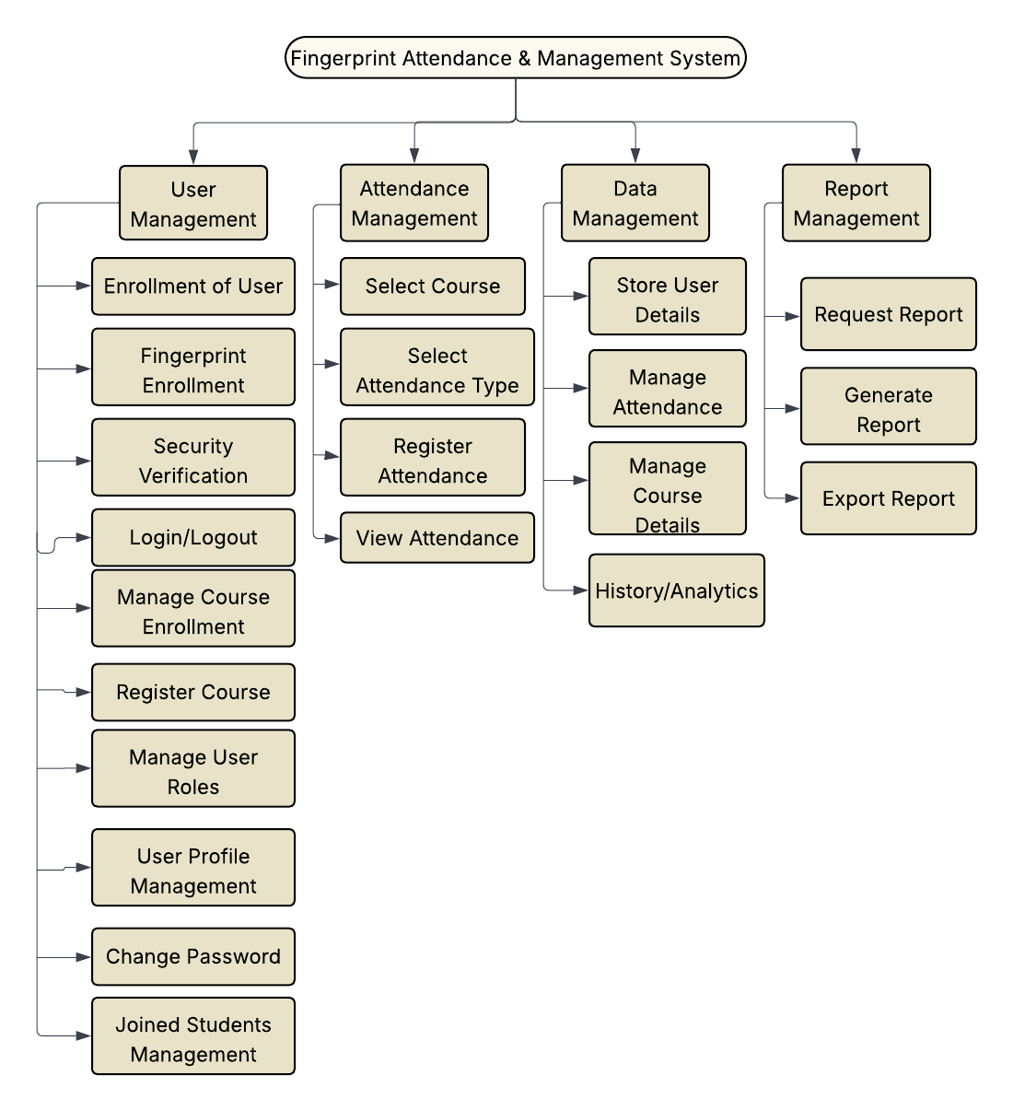

Figure 1: Functional Diagram

## **4.5 Context Diagram**

The context diagram provides a high-level view of the Fingerprint-Based Attendance and Management System, depicting its interactions with external entities such as users, biometric devices, and administrative systems.

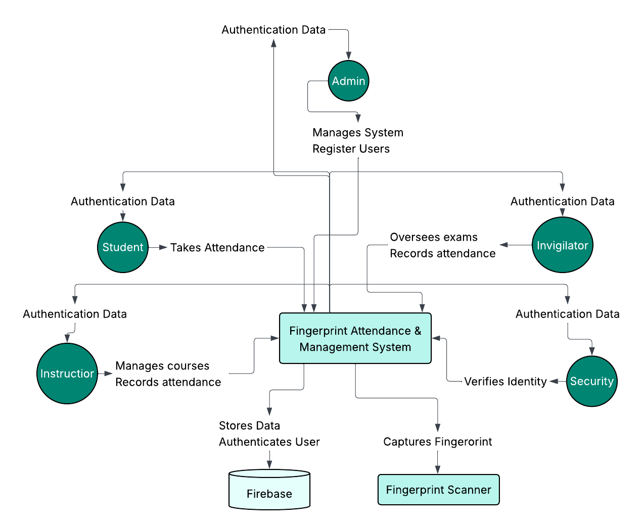It shows the system as a single process with data flows to and from external actors, illustrating the boundaries and scope of the system. This diagram helps in understanding the overall environment in which the system operates and the key interfaces involved.

***Figure 2: Context Diagram***

## **4.6 Data Flow Diagram (DFD)**

The **Data Flow Diagram** (DFD) represents the flow of data within the Fingerprint-Based Attendance and Management System. It illustrates how data moves between processes, data stores, and external entities.

The DFD helps in identifying the inputs, outputs, and storage points of data, providing a clear understanding of the system's data processing and management. It serves as a foundation for system design and implementation.

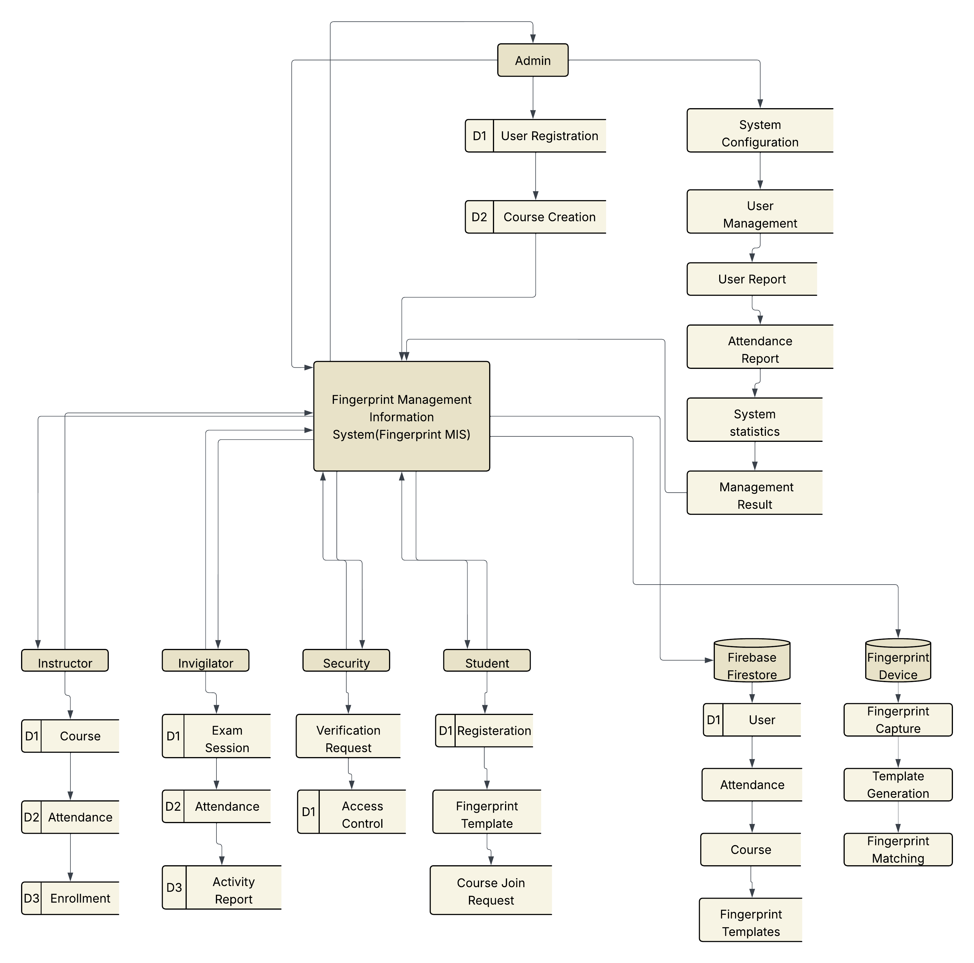**Dataflow Diagram level 0**

***Figure 3: Dataflow Diagram level 0 (Context Diagram)***

## **4.7.1 Dataflow Diagram Level 1 of User Management Process**

This diagram provides a detailed view of the User Management process within the Fingerprint-Based Attendance and Management System. It illustrates the sub-processes involved in user registration, authentication, role assignment, and profile management.

The diagram shows data inputs from users, interactions with the biometric enrollment module, and updates to the user database. It highlights the flow of information necessary to maintain accurate and secure user records.

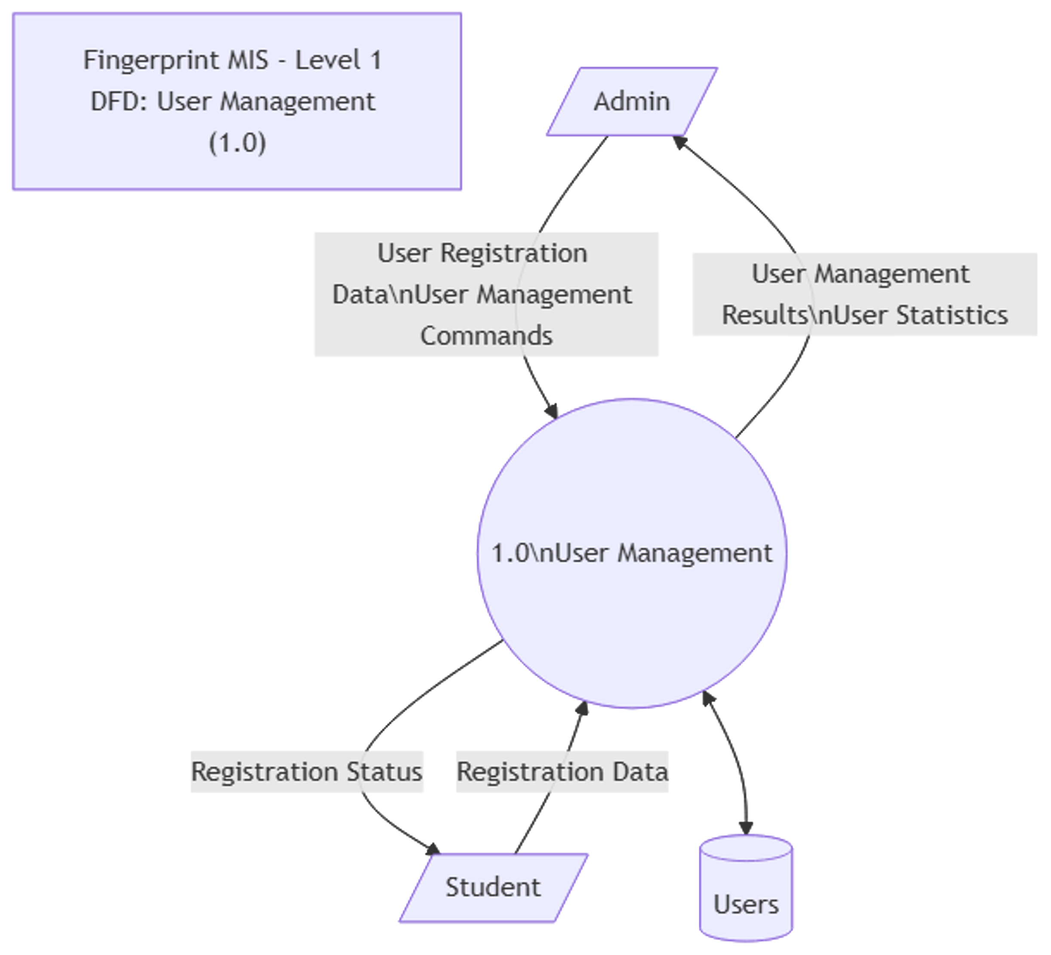

***Figure 4: Dataflow Diagram level 1 of User Management***

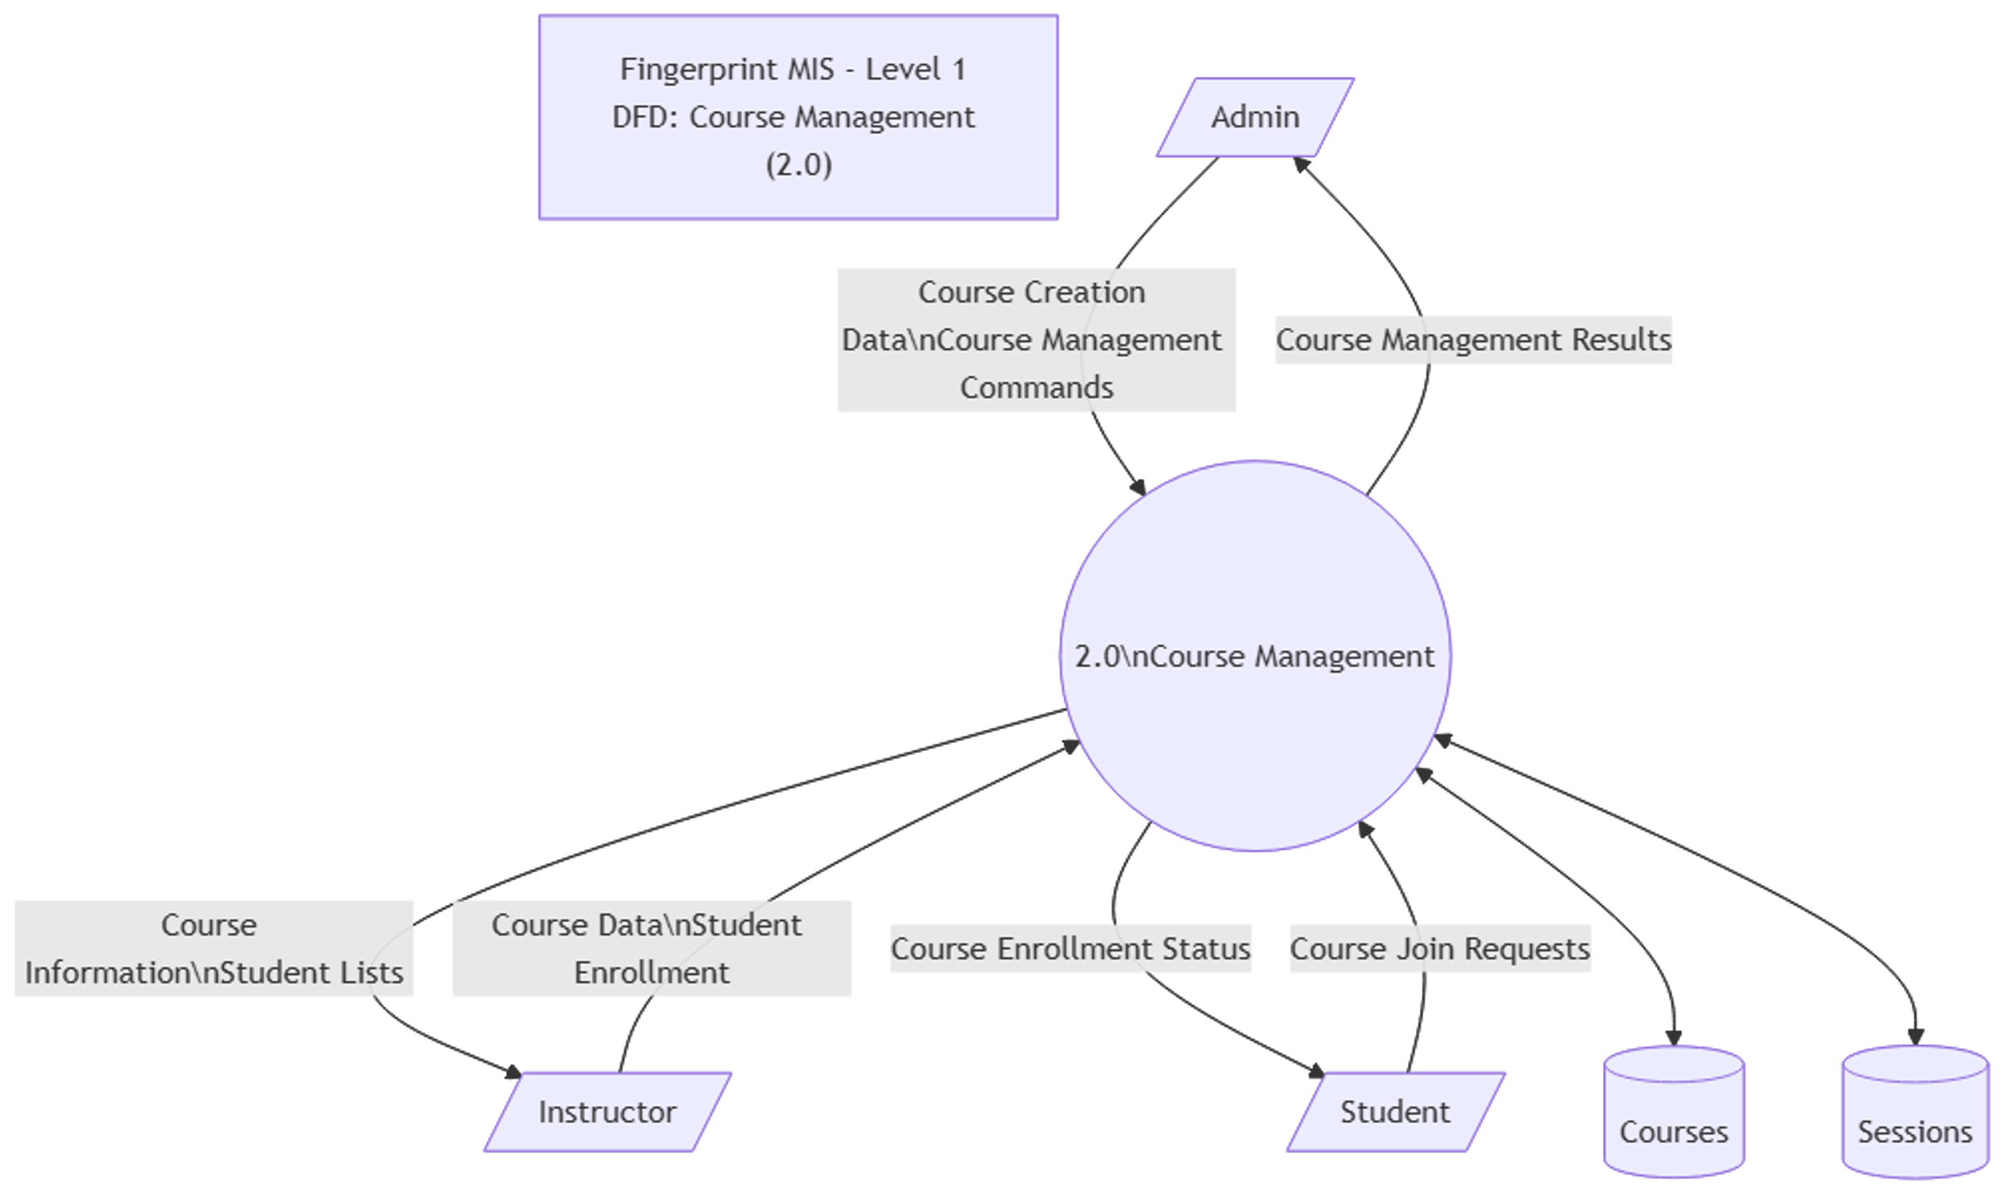

***Figure 5: Dataflow Diagram level 1 of Course Management***

## **4.7.2 Dataflow Diagram Level 1 of Attendance Management Process**

This diagram details the Attendance Management process, showing the flow of data related to attendance recording, verification, and reporting. It includes interactions with fingerprint verification modules, session management, and attendance databases.

The diagram highlights how attendance data is captured, validated, and stored, ensuring accurate and secure tracking of user attendance within the system.

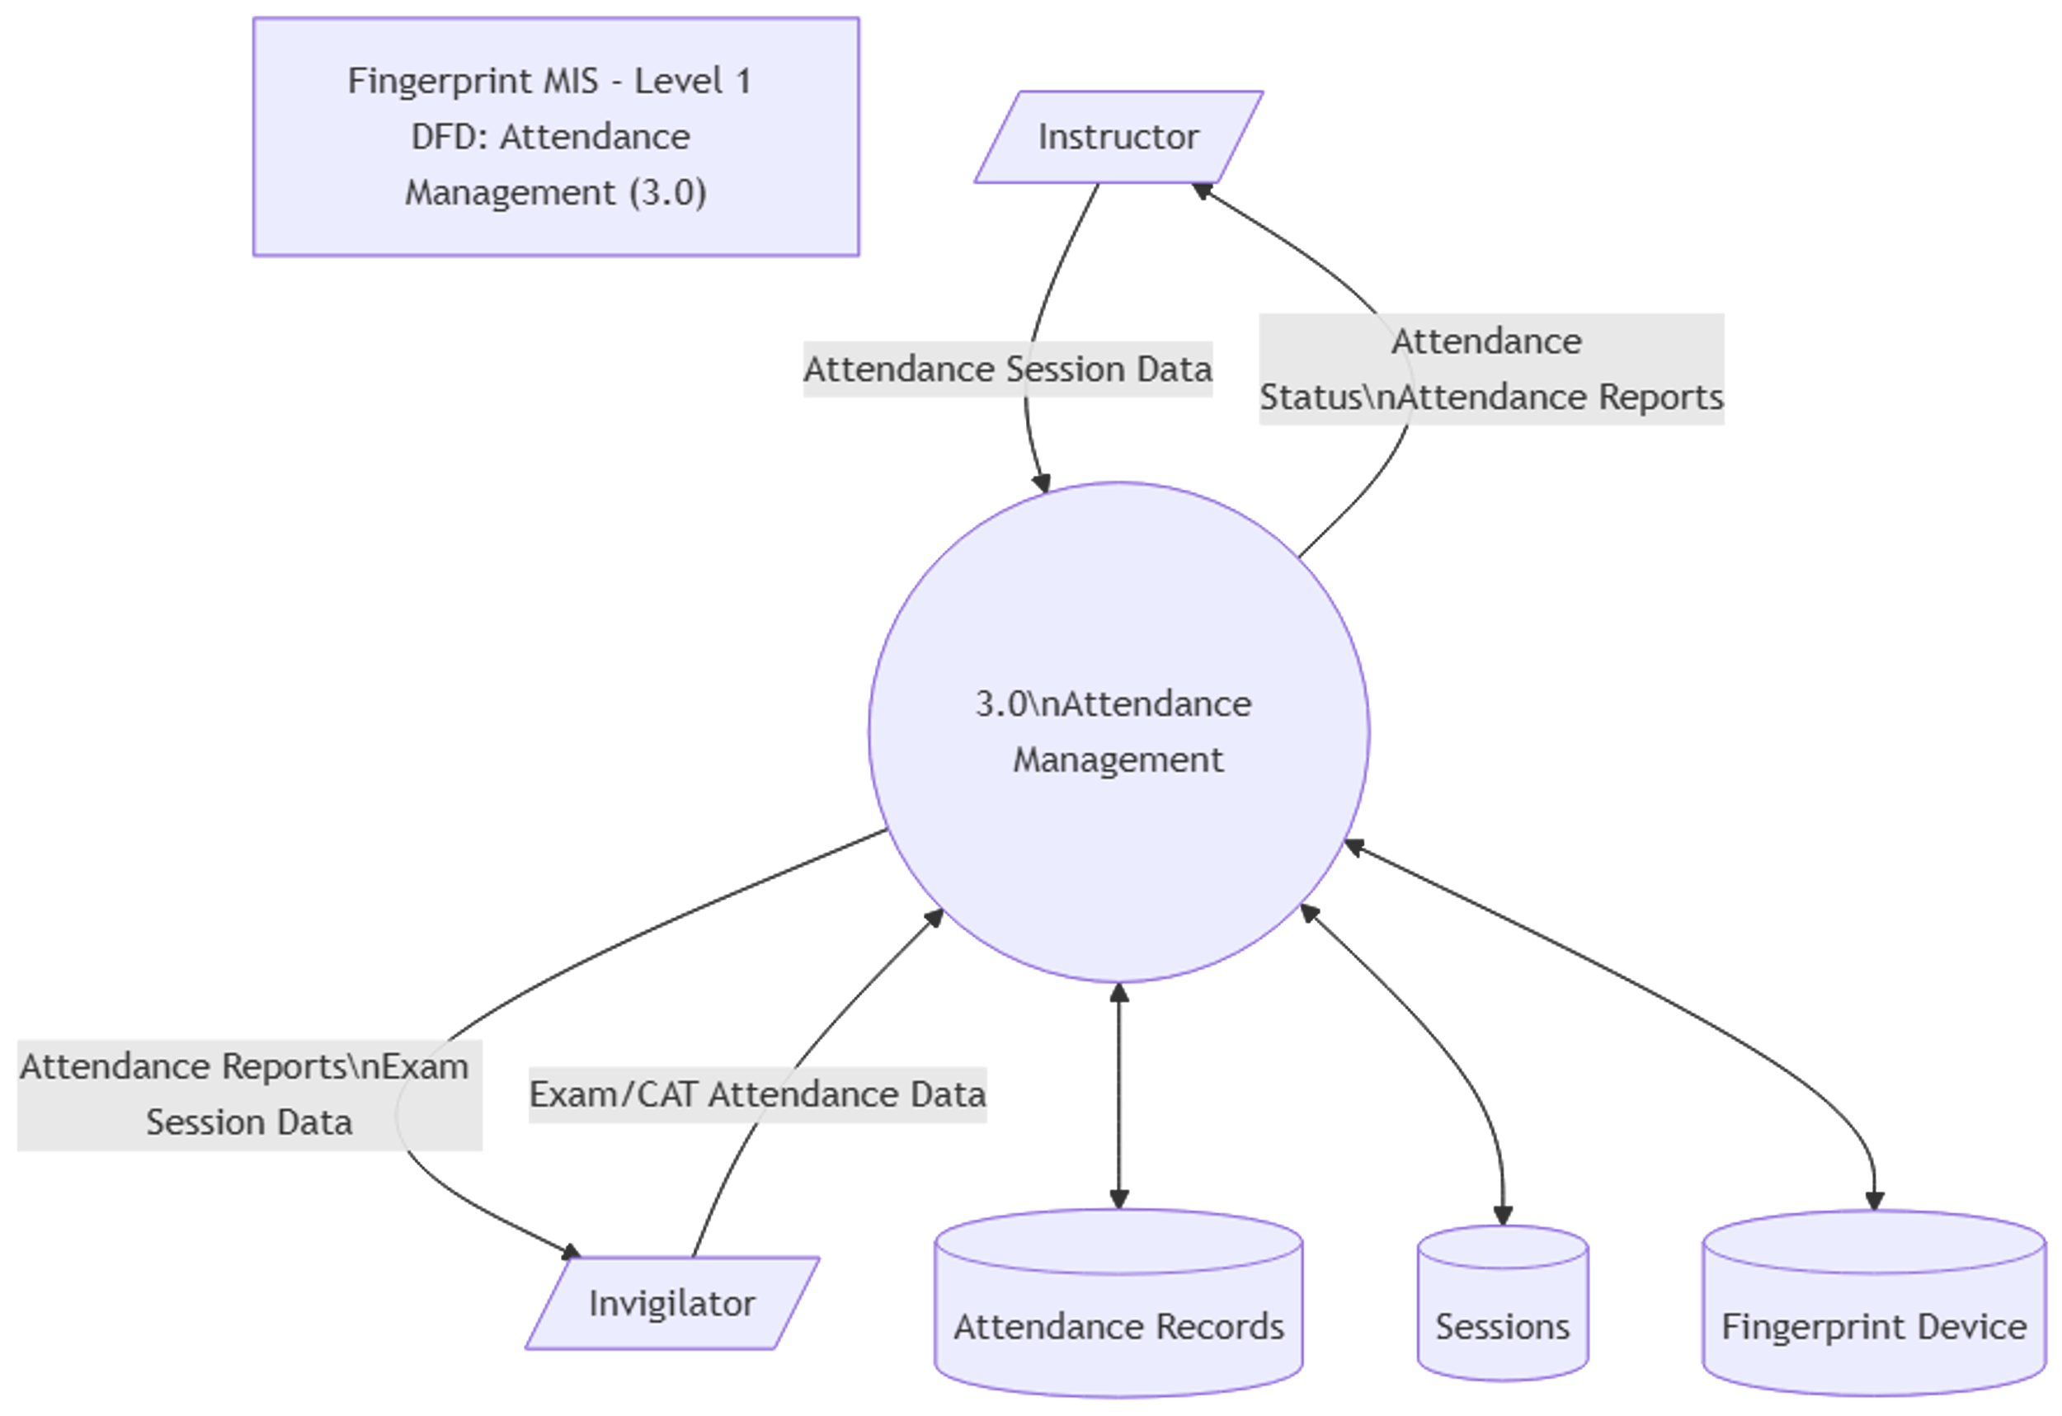

***Figure 6: Dataflow Diagram level 1 of Attendance Management***

## **4.7.3 Dataflow Diagram Level 1 of Data Management Process**

This diagram illustrates the Data Management process within the system, detailing how data is collected, stored, updated, and retrieved. It includes interactions with databases, backup systems, and data validation modules.

The diagram emphasizes data integrity, security, and efficient handling to support the overall functionality of the attendance and management system.

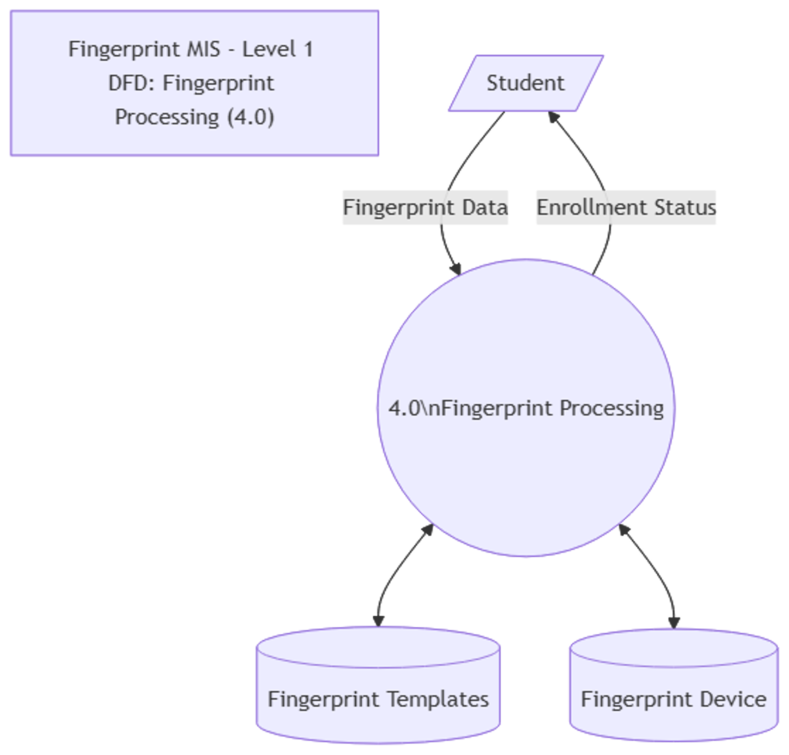

***Figure 7: Dataflow Diagram level 1 of Fingerprint Processing***

## **4.7.4 Dataflow Diagram Level 1 of Report Generation Process**

This diagram depicts the Report Management process, detailing how attendance and user data are compiled, analyzed, and presented in various report formats. It includes data aggregation, filtering, and visualization components.

The diagram highlights the flow of information from data stores to reporting modules, enabling administrators to generate insights and make informed decisions based on attendance trends and user activity.

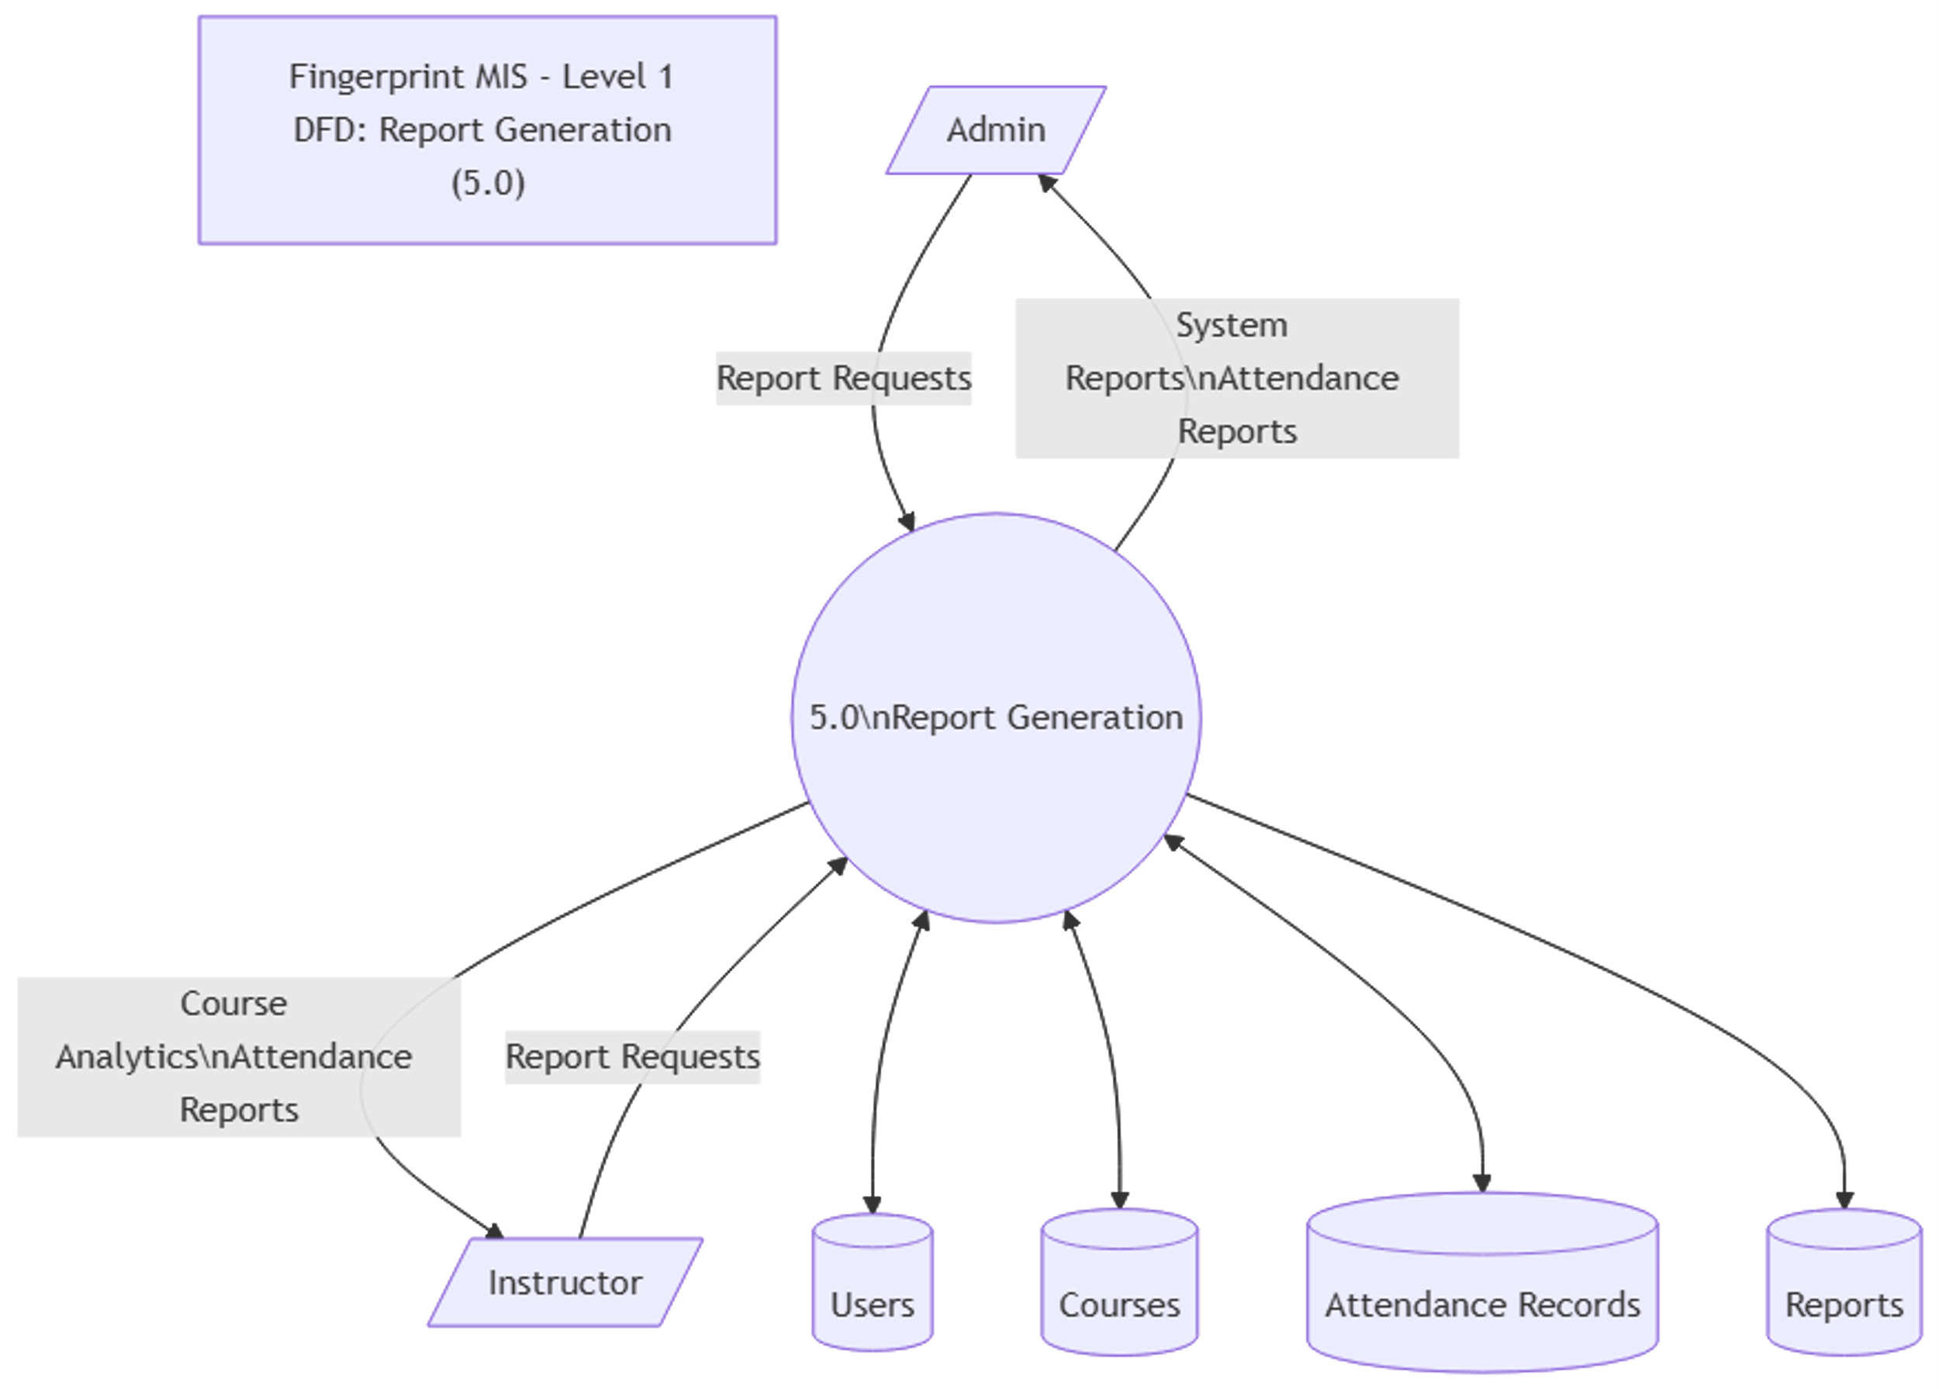

***Figure 8: Dataflow Diagram level 1 of Report Generation***

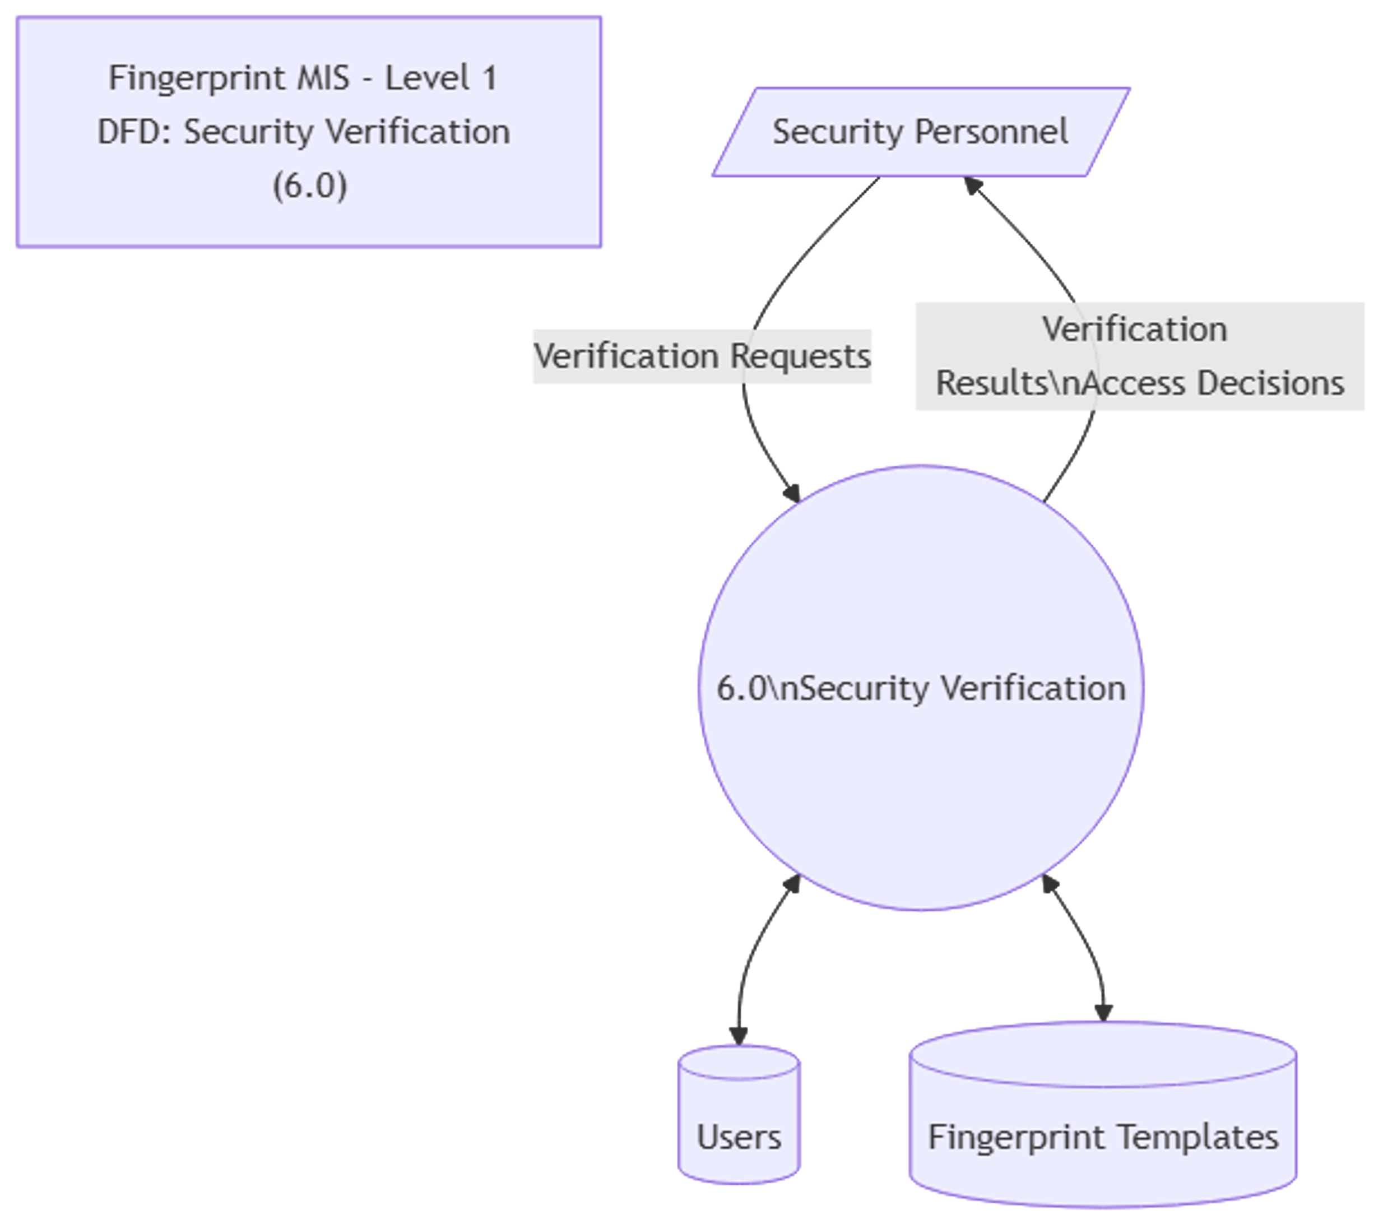

***Figure 9: Dataflow Diagram level 1 of Security Verification***

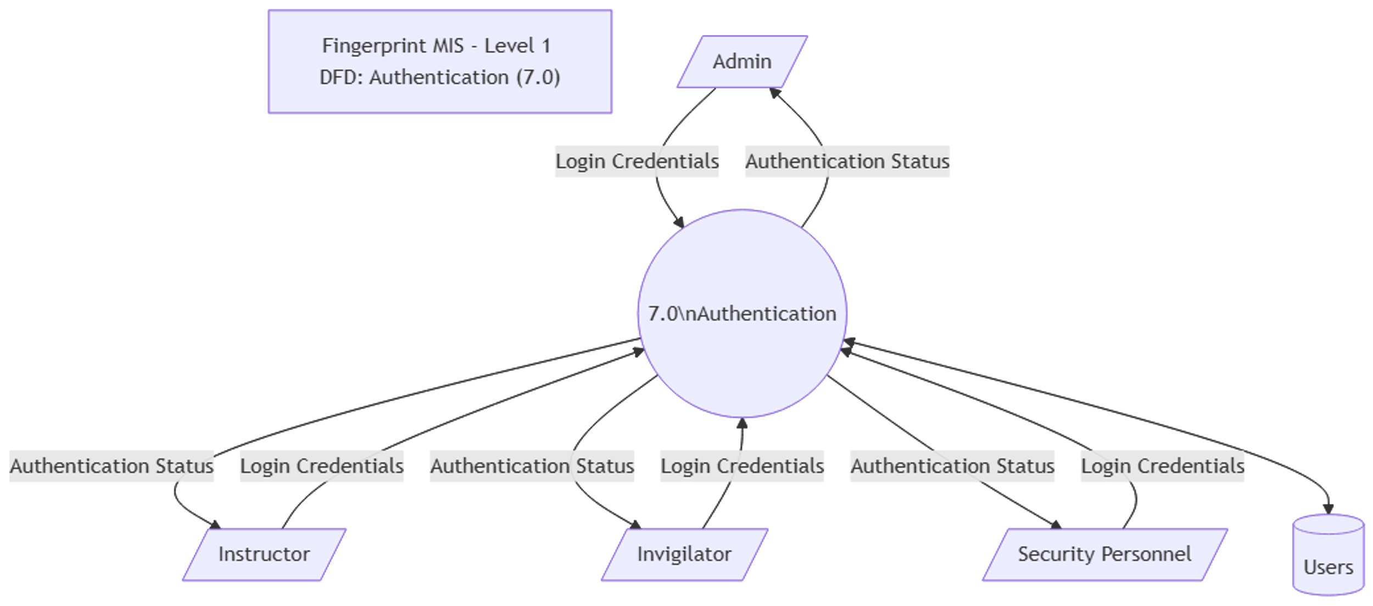

***Figure 10: Dataflow Diagram level 1 of Authentication***

## **4.8 Entity Relationship Diagram (ERD)**

The Entity Relationship Diagram (ERD) models the data entities, their attributes, and the relationships between them within the Fingerprint-Based Attendance and Management System. It provides a visual representation of the database structure, facilitating understanding of data organization and constraints.

Key entities include Users, Attendance Records, Sessions, Reports, and Roles. The ERD defines primary keys, foreign keys, and cardinality, ensuring data integrity and supporting efficient database design.

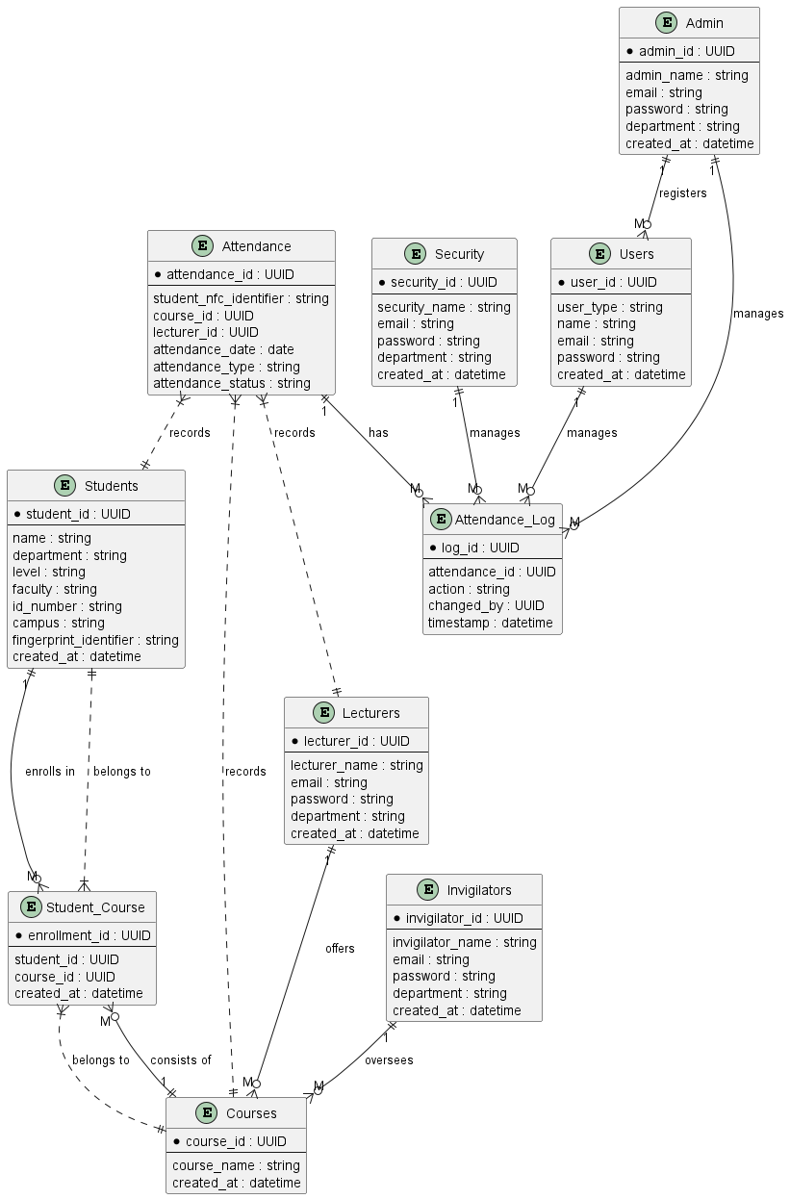

Figure 11: Entity Relationship Diagram

## **4.9 Logical Data Model**

The Logical Data Model defines the structure of data elements and their relationships without considering physical implementation details. It provides a blueprint for database design, focusing on entities, attributes, and normalization.

**Entities and Attributes**

**User**

  - UserID (Primary Key)

  - Name

  - Role (Admin, Student, Instructor, Invigilator, Security)

  - Email

  - Password

  - FingerprintID (Foreign Key)

**Course**

  - CourseID (Primary Key)

  - CourseName

  - Description

  - InstructorID (Foreign Key)

**Attendance**

  - AttendanceID (Primary Key)

  - SessionID (Foreign Key)

  - StudentID (Foreign Key)

  - Status (Present/Absent)

  - Timestamp

**Session**

  - SessionID (Primary Key)

  - CourseID (Foreign Key)

  - Date

  - Time

  - Location

**Fingerprint**

  - FingerprintID (Primary Key)

  - UserID (Foreign Key)

  - FingerprintData

  - EnrollmentDate

**Report**

  - ReportID (Primary Key)

  - GeneratedBy (UserID, Foreign Key)

  - DateGenerated

  - ReportType

  - Content

**2. Relationships**

- Users enroll in Courses.

- Instructors manage Courses.

- Students attend Sessions.

- Attendance records link Students to Sessions.

- Fingerprint data is linked to Users.

- Reports are generated by Admin or other roles.

**3. Diagram**

Include an Entity-Relationship Diagram (ERD) showing entities, attributes, and relationships with cardinalities.

## **4.9.1 Data Dictionary (DD)**

A **Data Dictionary** is a metadata repository that stores details about the database's structure and organization. It is an essential component of any database management system, providing information about the data, its attributes, relationships, and access rights.

The **Data Dictionary** is maintained by the database system itself and is typically inaccessible to regular users. It acts as a reference for the system to ensure data consistency and integrity.

**Purpose of a Data Dictionary:**

1. To store metadata about the database structure.
2. To maintain the schema and other details of database relations.
3. To ensure database integrity by storing constraints, domains, and attribute specifications.
4. To enable users and developers to understand the data organization.

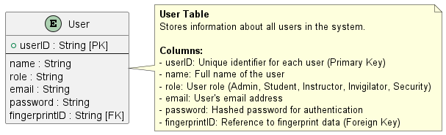

Table 1: User

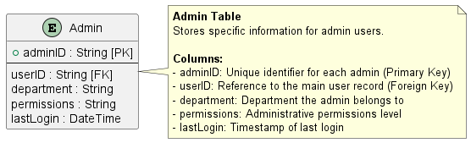

Table 2: Admin

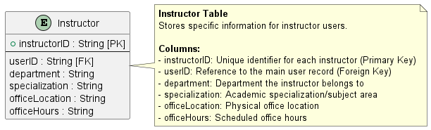

Table 3: Instructor

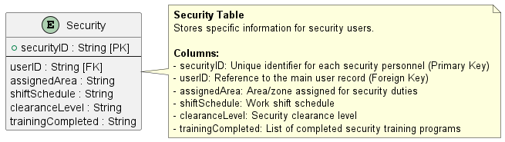

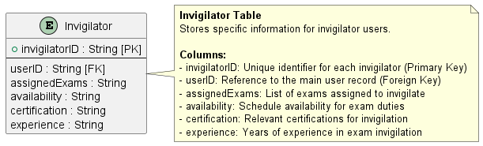Table 4: Security

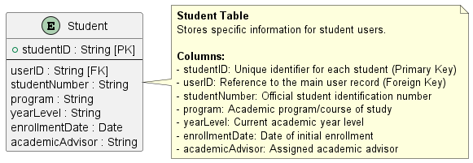Table 5: Invigilator

Table 6: Student

Table 7: Instructor Course

Table 8: Course Attendance

Table 9: Course Student

Table 10: Course

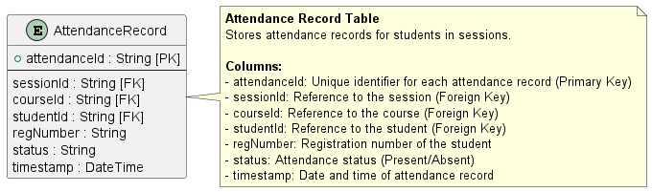

Table 11: Attendance Record

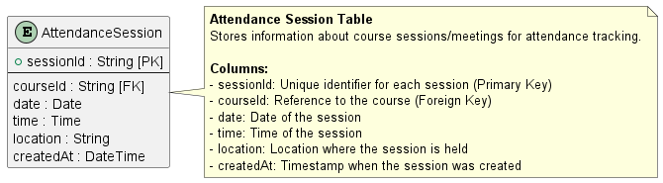

Table 12: Attendance Session

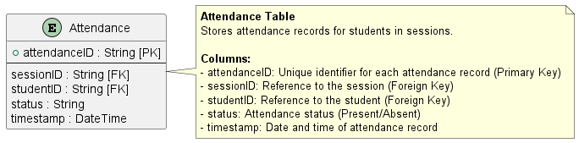

Table 13: Attendance

Table 14: Fingerprint

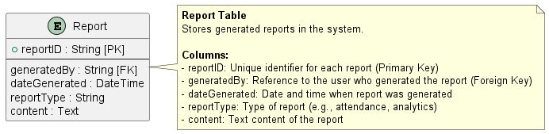

Table 15: Report

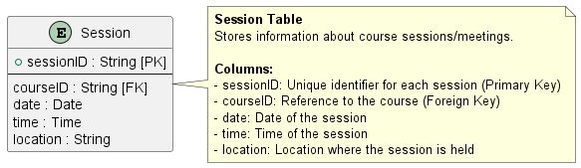

Table 16: Session

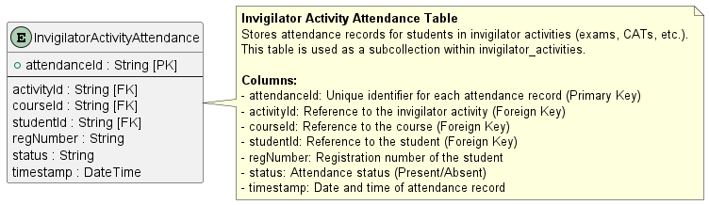

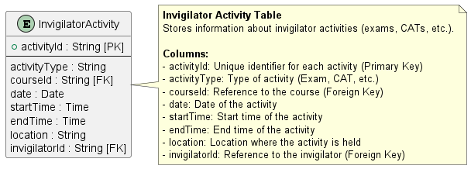Table 17: Invigilator Activity Attendance

Table 18: Invigilator Activity

## **4.9.2 Physical Data Model**

The Physical Data Model translates the logical design into a physical structure optimized for the chosen database system. It includes table definitions, indexes, constraints, and storage considerations to support efficient data access and integrity.

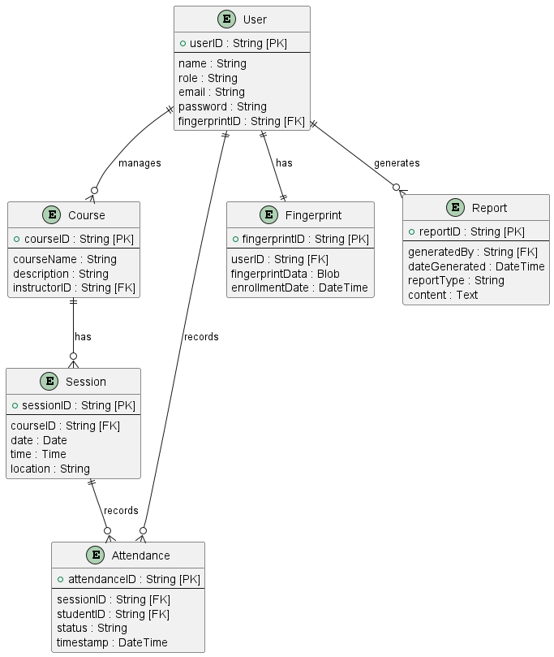

***Figure 12: Physical Data Model***

# **CHAPTER 5: IMPLEMENTATION OF NEW SYSTEM**

## **5.1 Introduction**

The implementation of the Fingerprint Management Information System (FingerprintMIS8) represents a comprehensive approach to modernizing attendance tracking in educational institutions. This chapter details the technical implementation of the system, covering the architecture, development process, and integration of various components that make up the complete solution.

## **5.2 System Architecture**

The FingerprintMIS8 system follows a client-server architecture with Flutter as the frontend framework and Firebase as the backend service. The system is designed with a multi-tier architecture that separates concerns between user interface, business logic, and data management.

## **5.2.1 Frontend Architecture**

The frontend is built using Flutter, Google's UI toolkit for building natively compiled applications for mobile, web, and desktop from a single codebase. The application follows a widget-based architecture where each screen is composed of reusable components.

Key components of the frontend architecture include:

* **Main Application Entry Point**: The main.dart file serves as the entry point, initializing Firebase and setting up routing for different user roles.
* **Role-Based Routing**: The system implements distinct routes for each user type (Admin, Instructor, Invigilator, Security, Student) with their respective dashboards and functionalities.
* **State Management**: Each page implements StatefulWidget for managing local state and user interactions.
* **5.2.2 Backend Architecture**

Firebase serves as the backend infrastructure, providing several critical services:

* **Firebase Authentication**: Manages user authentication and role-based access control
* **Cloud Firestore**: NoSQL database for storing user data, courses, attendance records, and system configurations
* **Firebase Storage**: Storage for fingerprint templates and other binary data
* **Firebase Functions**: Serverless functions for email notifications and background processing

## **5.3 Implementation Details**

## **5.3.1 User Management System**

The system implements a comprehensive user management system with five distinct roles:

1. **Admin Implementation**:
   * Admin registration through admin_registration_page.dart
   * Full system access with user management capabilities
   * Course creation and management functionalities
2. **Instructor Implementation**:
   * Registration with default password system
   * Course management and attendance tracking
   * Student enrollment and performance monitoring
3. **Invigilator Implementation**:
   * Specialized role for exam supervision
   * Attendance tracking for examination periods
   * Activity-specific attendance recording (CAT, EXAM, CONFERENCE)
4. **Security Implementation**:
   * Student verification processes
   * Fingerprint scanning and validation
   * Access control for restricted areas
5. **Student Implementation**:
   * Fingerprint enrollment and verification
   * Attendance participation
   * Profile management

## **5.3.2 Fingerprint Integration**

The fingerprint functionality is implemented through a custom SDK wrapper (fingerprint_sdk.dart) that abstracts the underlying fingerprint scanning hardware. Key implementation aspects include:

* **Fingerprint Enrollment**: Students register their fingerprints through a dedicated enrollment page
* **Template Storage**: Fingerprint templates are securely stored in Firestore
* **Verification Process**: Real-time fingerprint matching for attendance recording

## **5.3.3 Attendance Tracking System**

The attendance system is designed with flexibility for different scenarios:

1. **Instructor-Led Attendance**:
   * Course-specific attendance sessions
   * Real-time scanning and recording
   * Immediate feedback to students
2. **Invigilator Activity Attendance**:
   * Specialized tracking for examination periods
   * Activity type categorization (CAT, EXAM, CONFERENCE)
   * Detailed reporting capabilities
3. **Security Verification**:
   * Student identity verification
   * Access control for restricted areas
   * Audit trail generation

## **5.3.4 Data Management**

The system implements a structured data model using Firestore collections:

* **User Collections**: Separate collections for admins, instructors, invigilators, security personnel, and students
* **Course Collections**: Course definitions and student enrollments
* **Attendance Collections**: Attendance records with timestamps and metadata
* **Configuration Collections**: System settings and parameters

**5.4 Security Implementation**

The system incorporates multiple layers of security:

1. **Authentication**:
   * Firebase Authentication for user login
   * Role-based access control
   * Default password system with forced change policy
2. **Data Security**:
   * Secure storage of fingerprint templates
   * Encrypted communication with Firebase services
   * Temporary security rules (to be strengthened for production)
3. **Email Notifications**:
   * Automated welcome emails for new users
   * Password change notifications
   * System event alerts

## **5.5 User Interface Implementation**

The user interface follows Material Design principles with a consistent deep purple color scheme. Each role has a dedicated dashboard with role-appropriate functionality:

* **Admin Dashboard**: Comprehensive system controls and analytics
* **Instructor Dashboard**: Course management and student performance tracking
* **Invigilator Dashboard**: Exam supervision tools
* **Security Dashboard**: Student verification interface

## **5.6 Integration Points**

The system integrates with several external services:

1. **Firebase Services**:
   * Authentication for user management
   * Firestore for data storage
   * Cloud Functions for server-side logic
   * Storage for fingerprint templates
2. **Email Services**:
   * Nodemailer integration for email notifications
   * Automated welcome emails for new users
3. **Fingerprint Hardware**:
   * SDK wrapper for fingerprint scanning devices
   * Template matching algorithms

## **5.7 Development Environment**

The system was developed using:

* Flutter SDK for cross-platform compatibility
* Dart programming language
* Firebase services for backend infrastructure
* Visual Studio Code as the primary IDE
* PlantUML for system documentation and diagrams

## **5.8 Deployment Considerations**

The implementation follows best practices for deployment:

* Environment-specific configurations
* Secure credential management
* Scalable database design
* Responsive UI for various device sizes

## **5.9 Challenges and Solutions**

During implementation, several challenges were addressed:

1. **Multi-Role System Complexity**:
   * Solution: Implemented clear role-based routing and permission systems
2. **Fingerprint Integration**:
   * Solution: Created abstraction layer through fingerprint SDK
3. **Data Consistency**:
   * Solution: Used Firestore transactions for critical operations
4. **User Experience**:
   * Solution: Implemented consistent UI patterns and feedback mechanisms

## **5.10 Sample interfaces**

## **5.10.1 Login page**

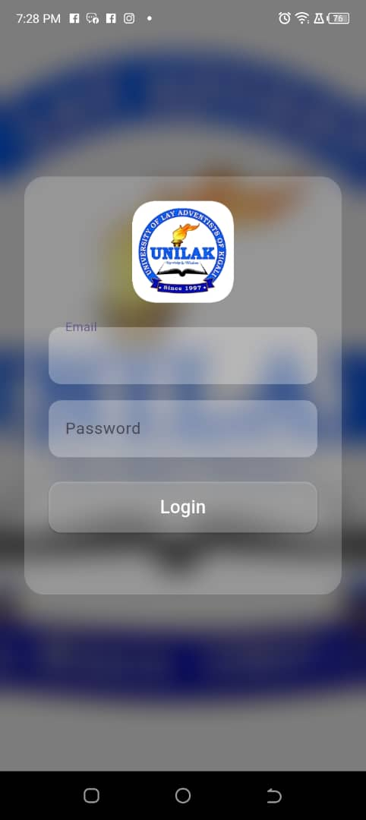

### ***Figure 13: Login Page***

## **5.10.2 Dashboards**

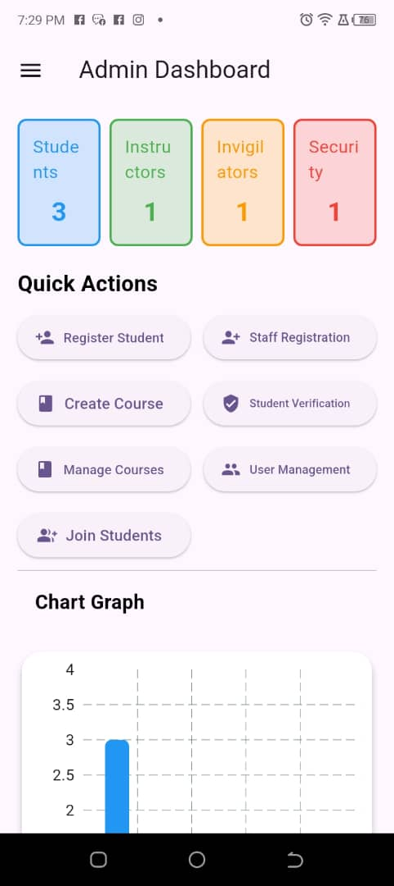

### ***Figure 14: Admin Dashboard***

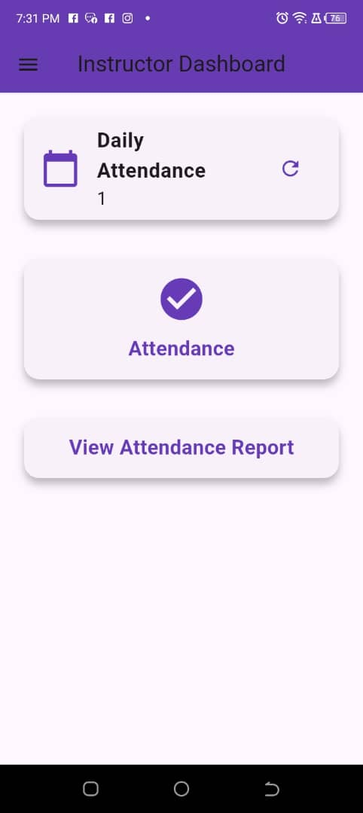

### ***Figure 15: Instructor Dashboard***

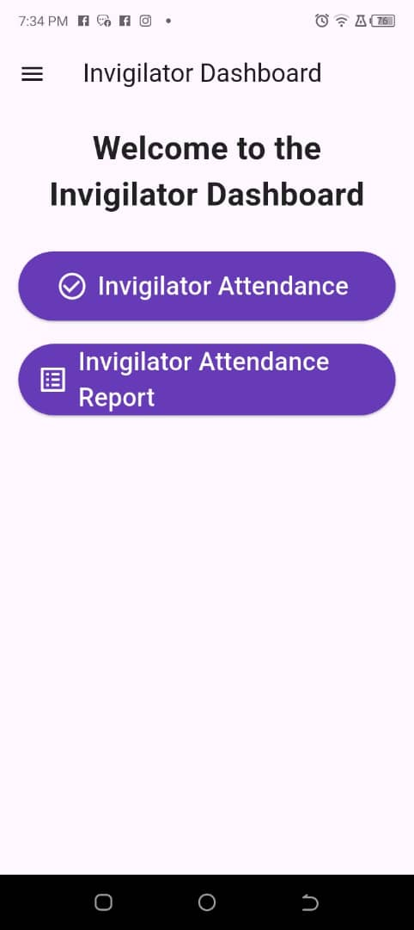

### ***Figure 16: Invigilator Dashboard***

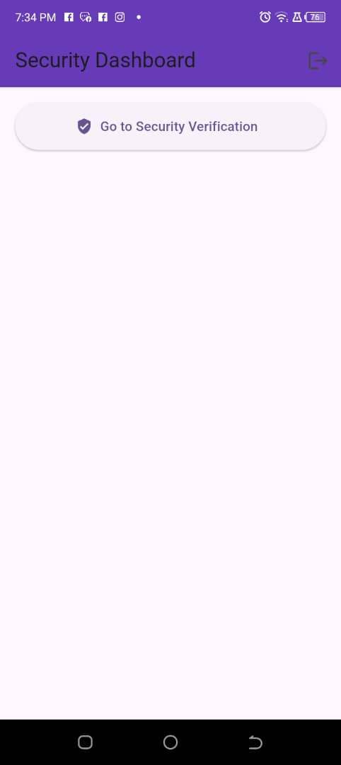

### ***Figure 17: Security Dashboard***

## **5.10.3 Fingerprint &Attendance pages**

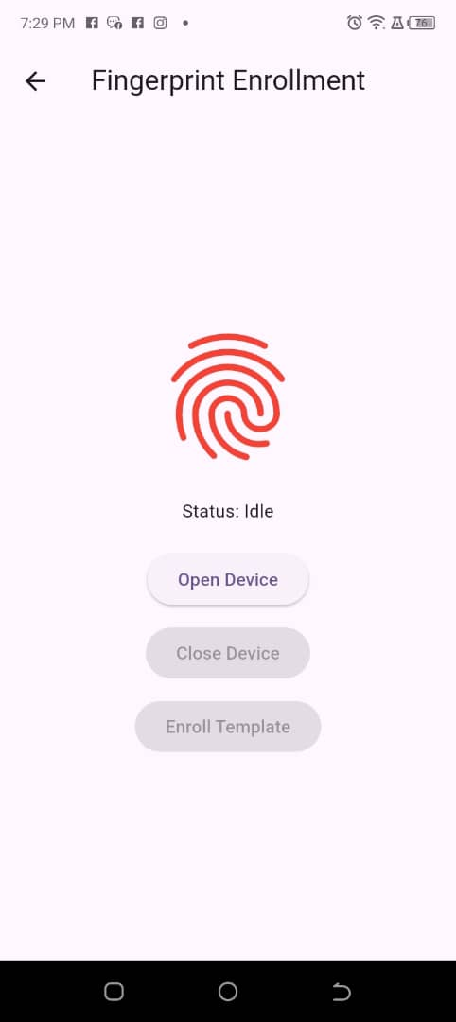

### ***Figure 18: Fingerprint Enrollment Page***

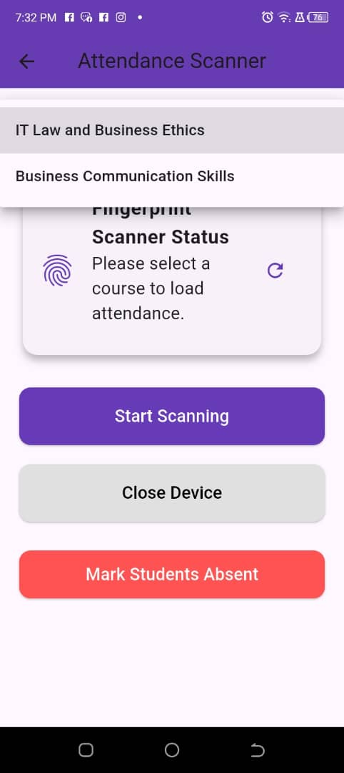

### ***Figure 19: Fingerprint Attendance Page***

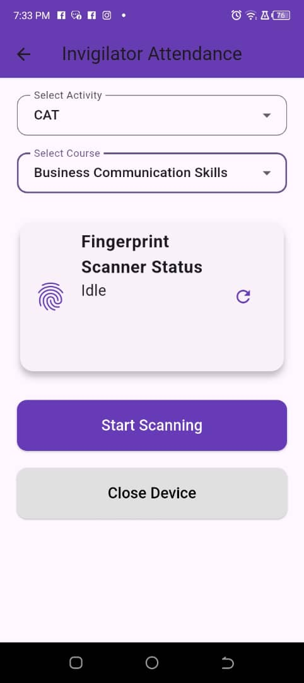

### ***Figure 20: Fingerprint CAT/EXAM/CONFERENCE Attendance Page***

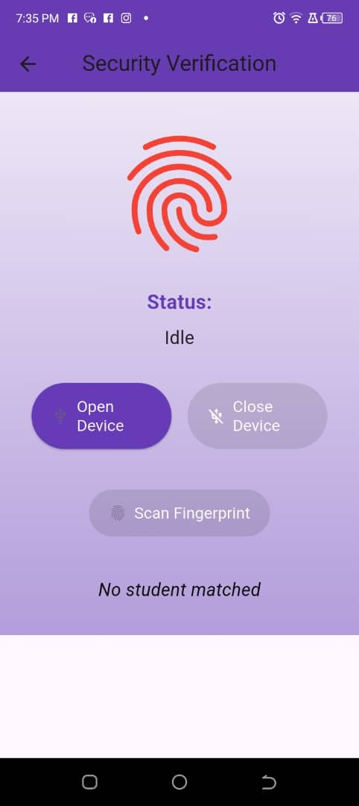

### ***Figure 21: Fingerprint Verification Page***

## **5.10.4 Reports Pages**

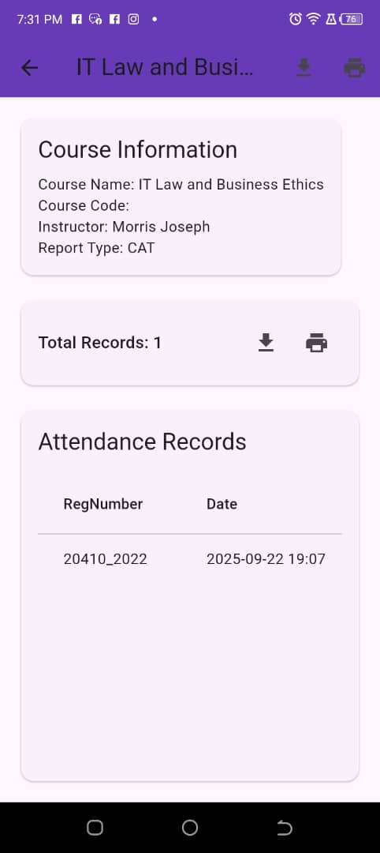

### ***Figure 22: Admin Report Page***



### ***Figure 23: Instructor Report Page***

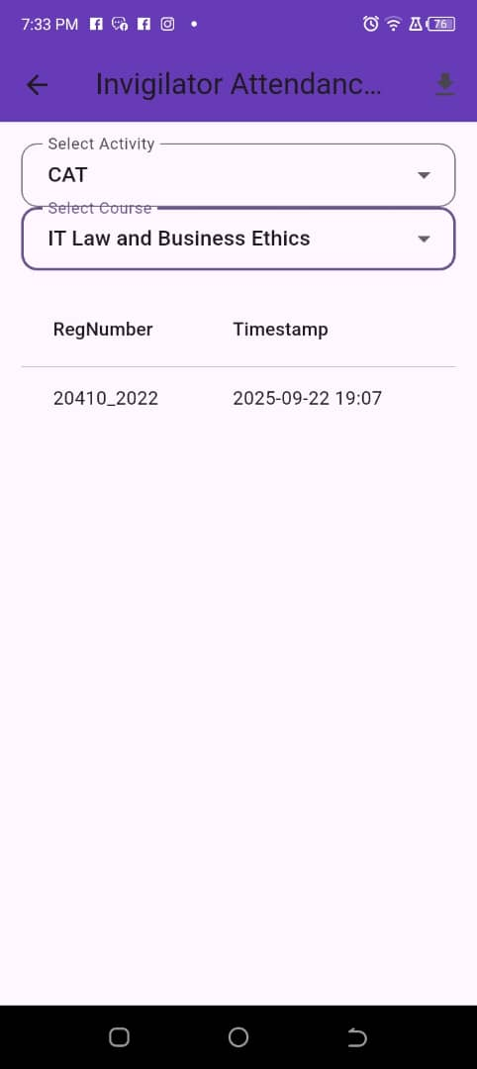

### ***Figure 24: Invigilator Report Page***

# **Chapter Six: Summary, Conclusion, and Recommendations**

## **6.1 General Conclusion**

The Fingerprint Management Information System (FingerprintMIS8) project represents a significant technological advancement in attendance tracking for educational institutions. Through the successful implementation of a Flutter-based mobile application integrated with Firebase services, this project has effectively addressed the limitations of traditional attendance methods by introducing a secure, efficient, and user-friendly fingerprint-based solution.

The system's multi-role architecture successfully accommodates five distinct user categories: Admin, Instructor, Invigilator, Security, and Student. Each role is equipped with tailored functionalities that align with their specific responsibilities within an educational environment. This role-based approach ensures optimal user experience while maintaining appropriate access controls and data privacy.

The integration of biometric technology through a custom fingerprint SDK wrapper demonstrates the feasibility of incorporating advanced authentication mechanisms in educational applications. The enrollment and verification processes provide a robust foundation for accurate attendance tracking, effectively eliminating issues of proxy attendance that plague traditional methods.

The system's data management capabilities, powered by Firebase Firestore, implement a well-structured data model that efficiently organizes user information, course details, attendance records, and system configurations. The implementation includes proper indexing strategies that optimize query performance, ensuring responsive operation even with substantial data volumes.

From a user experience perspective, the application adheres to Material Design principles, providing a consistent and intuitive interface across all user roles. The deep purple color scheme and thoughtful UI components contribute to a professional appearance that enhances user engagement.

The security infrastructure incorporates multiple protective layers, including Firebase Authentication for robust user verification and role-based access controls that safeguard sensitive information. The implementation of automated email notifications through Firebase Functions improves the user onboarding experience and system communication.

The project's comprehensive documentation, including detailed PlantUML diagrams, provides valuable insights into the system's architecture, data flow, and entity relationships. This documentation serves as an essential resource for future maintenance, enhancement, and knowledge transfer.

Overall, the FingerprintMIS8 project successfully demonstrates the practical application of modern mobile development technologies in solving real-world educational challenges. The system provides a scalable, maintainable, and effective solution that can significantly improve administrative efficiency while enhancing academic integrity.

## **6.2 Recommendations**

Based on the development experience and analysis of the FingerprintMIS8 system, the following recommendations are proposed for future enhancement and deployment:

## **6.2.1 Security Enhancements**

1. **Permanent Security Rule Implementation**: Replace the temporary Firestore security rules with comprehensive, role-based security policies that provide granular access control for different user types and data collections. This is critical for production deployment to ensure data privacy and system integrity.
2. **Advanced Data Encryption**: Implement end-to-end encryption for highly sensitive data, particularly fingerprint templates and personal identification information, to enhance privacy protection and comply with data protection regulations.
3. **Multi-Factor Authentication**: Add two-factor authentication options for administrative users to provide an additional layer of security for privileged accounts.

## **6.2.2 System Integration and Interoperability**

1. **Institutional System Integration**: Develop APIs or integration modules to connect with existing student information systems, learning management systems, and institutional databases to enable seamless data exchange and reduce manual data entry.
2. **Calendar Integration**: Implement integration with academic calendars to automatically schedule attendance sessions based on class timetables and academic schedules.
3. **Enhanced Reporting Module**: Expand the reporting capabilities to include more advanced analytics, such as attendance trends, performance correlations, and predictive modeling to support data-driven decision making.

## **6.2.3 User Experience Improvements**

1. **Offline Functionality**: Implement offline capabilities for attendance recording in areas with limited connectivity, with automatic synchronization when connectivity is restored to ensure uninterrupted system operation.
2. **Accessibility Features**: Enhance the application with accessibility features to support users with disabilities, including screen reader compatibility, high contrast modes, and adjustable UI elements.
3. **Multi-language Support**: Implement internationalization to support multiple languages, making the system accessible to diverse user populations in multicultural educational environments.

## **6.2.4 Technical Enhancements**

1. **Performance Optimization**: Conduct comprehensive performance testing and optimization to ensure smooth operation with large numbers of concurrent users and extensive data sets.
2. **Advanced Fingerprint Algorithms**: Investigate and implement more sophisticated fingerprint matching algorithms to improve accuracy and reduce false positives/negatives, particularly in challenging environmental conditions.
3. **Comprehensive Backup and Recovery**: Implement automated backup and disaster recovery mechanisms for critical data to ensure business continuity and data protection.

## **6.2.5 Feature Expansion**

1. **Enhanced Notification System**: Develop a comprehensive notification system that includes SMS, push notifications, and email alerts for important events, reminders, and system updates.
2. **Progressive Web Application**: Create a progressive web application (PWA) version to provide browser-based access without requiring app installation, expanding accessibility across different devices.
3. **Advanced Analytics Dashboard**: Design a comprehensive analytics dashboard for administrators with visual representations of attendance patterns, system usage metrics, and performance indicators.

## **6.2.6 Testing and Quality Assurance**

1. **Automated Testing Implementation**: Establish comprehensive automated testing suites, including unit tests, integration tests, and UI tests to ensure ongoing system reliability and facilitate future development.
2. **User Acceptance Testing**: Conduct extensive user acceptance testing with actual educational institutions to gather feedback and identify real-world usage scenarios and potential improvements.
3. **Regular Security Auditing**: Implement a schedule for regular security audits to identify and address potential vulnerabilities and ensure continued system security.

# **References**

1. Abate, A. F., Nappi, M., & Vitulano, D. (2007). Fingerprint verification using Delaunay triangulation. In Proceedings of the 2007 ACM workshop on Multimedia and security (pp. 81-86).
2. Bolle, R. M., Connell, J. H., & Pankanti, S. (2000). Biometric perils and patches. Pattern Recognition, 33(9), 1473-1480.
3. Cappelli, R., Lumini, A., Maio, D., & Maltoni, D. (1999). Fingerprint classification by directional image partitioning. IEEE Transactions on Pattern Analysis and Machine Intelligence, 21(5), 402-421.
4. Firebase Documentation. (2023). Firebase Authentication. Retrieved from <https://firebase.google.com/docs/auth>
5. Flutter Documentation. (2023). Flutter Framework Overview. Retrieved from <https://flutter.dev/docs>
6. Google Developers. (2023). Cloud Firestore Documentation. Retrieved from <https://firebase.google.com/docs/firestore>
7. Jain, A. K., & Ross, A. (2002). Learning texture representation for biometric authentication. In Proceedings of the Fifth IEEE International Conference on Automatic Face and Gesture Recognition (pp. 408-413).
8. Jain, A. K., Ross, A., & Prabhakar, S. (2004). An introduction to biometric recognition. IEEE Transactions on Circuits and Systems for Video Technology, 14(1), 4-20.
9. Maltoni, D., Maio, D., Jain, A. K., & Prabhakar, S. (2009). Handbook of fingerprint recognition. Springer Science & Business Media.
10. Ratha, N. K., Connell, J. H., & Bolle, R. M. (2001). Enhancing security and privacy in biometrics-based authentication systems. IBM systems Journal, 40(3), 614-634.
11. Reilly, C., & Yekutiel, H. (2019). Student Attendance Monitoring Using Fingerprint Recognition. International Journal of Advanced Computer Science and Applications, 10(4), 378-385.
12. Ross, A., & Jain, A. K. (2002). Fusing multiple palmprint representations for improved recognition performance. In Proceedings of the 16th International Conference on Pattern Recognition (pp. 226-229).
13. Wayman, J. L., Jain, A. K., Kent, D., & Maltoni, D. (2005). Biometric systems: technology, design and performance evaluation. Springer Science & Business Media.
14. Yoon, S., Park, J., & Lee, S. (2018). Development of Fingerprint-Based Attendance Management System. Journal of Information Processing Systems, 14(6), 1325-1336.
15. Zhang, J., & Yang, W. (2020). Design and Implementation of Student Attendance Management System Based on Fingerprint Recognition. International Journal of Information and Communication Technology Education, 16(2), 1-12.

# **APPENDIX**

**Database Structure Examples**

Based on the analysis of the FingerprintMIS8 project, here are some examples of the database structure implemented using Firebase Firestore:

**User Collections Structure**

// Admin Collection

admins: {

userId: {

name: string,

email: string,

role: "admin"

}

}

// Instructor Collection

instructors: {

userId: {

name: string,

email: string,

role: "instructor",

defaultPassword: boolean,

passwordSetTime: timestamp

}

}

// Student Collection

students: {

userId: {

name: string,

email: string,

regNumber: string,

role: "student",

fingerprintTemplate: binary_data,

enrolledCourses: array

}

}

**Course Collection Structure**

// Courses Collection

courses: {

courseId: {

courseName: string,

courseCode: string,

instructorId: string,

createdAt: timestamp,

isActive: boolean

}

}

// Course-Student Relationship

course_students: {

courseId_studentId: {

courseId: string,

studentId: string,

enrollmentDate: timestamp

}

}

**Attendance Collection Structure**

// Attendance Collection

attendance: {

attendanceId: {

courseId: string,

sessionId: string,

studentId: string,

regNumber: string,

timestamp: timestamp,

verificationMethod: string,

location: string

}

}

**Firebase Security Rules Example**

rules_version = '2';

service cloud.firestore {

match /databases/{database}/documents {

// Temporary rule - should be replaced with proper security rules

match /{document=**} {

allow read, write: if request.time < timestamp.date(2025, 8, 1);

}

}

}

**Firebase Function for Email Notifications**

const functions = require('firebase-functions');

const admin = require('firebase-admin');

const nodemailer = require('nodemailer');

admin.initializeApp();

const transporter = nodemailer.createTransport({

service: 'gmail',

auth: {

user: 'eg8217178@gmail.com',

pass: 'blbugxtrbhzlwtfj'

}

});

exports.sendWelcomeEmail = functions.firestore

.document('{collectionId}/{userId}')

.onCreate(async (snap, context) => {

const userData = snap.data();

const email = userData.email;

const collectionId = context.params.collectionId;

// Only send email for specific collections

if (!['instructors', 'security', 'invigilators'].includes(collectionId)) {

console.log('Document created in collection', collectionId, '- no email sent.');

return null;

}

const defaultPassword = userData.defaultPassword ? 'DefaultPass123!' : null;

let emailText = `Hello,

Your account has been successfully created.

Login details:

Email: ${email}

`;

if (defaultPassword) {

emailText += `

Your temporary password is: ${defaultPassword}

Please change your password within 24 hours after your first login.

`;

} else {

emailText += `

Please use the password you set during registration to log in.

`;

}

emailText += `

If you forgot your password, please use the password reset option.

Thank you,

Fingerprint MIS Team`;

const mailOptions = {

from: 'Fingerprint Attendance <eg8217178@gmail.com>',

to: email,

subject: 'Welcome to Fingerprint MIS - Your Login Details',

text: emailText

};

try {

await transporter.sendMail(mailOptions);

console.log('Welcome email sent to:', email);

} catch (error) {

console.error('Error sending welcome email:', error);

}

});